Joseph Sidney Perilloux
January 19, 1895 – November 5, 1963

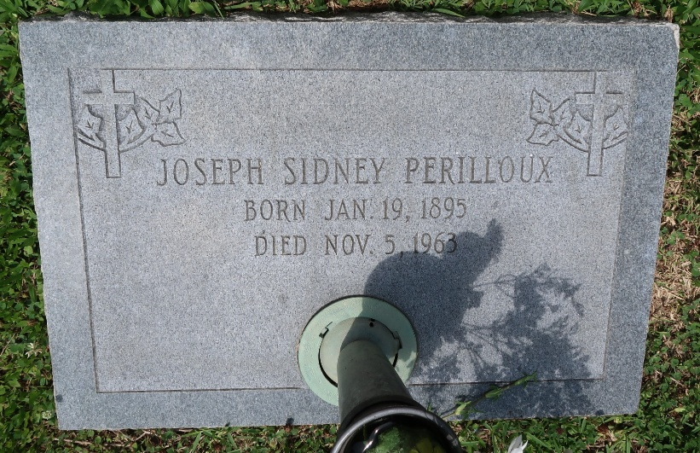

PERILLOUX-On Tuesday, November 5, 1963, at 7:40 o'clock a.m.
JOSEPH S PERILLOUX, beloved husband of Clothilde Millet, father of Mrs. Enoch Falterman, Arthur, Elliot, and Mrs. Donald McTopy of Montz, La, Joseph Jr and Mrs. Mike Milioto of Laplace, La, and Mrs. of Norco, La, also survived by 23 grandchildren, age 68 years, a native of Montz, La.
Relatives and friends of the family, also employees of National Gypsum Company of Good Hope, La, Shell Oil and Shell Chemical of Norco, G.H.T.X. Car Shop of Good Hope and St Charles Parish Board of Trade are invited to attend the funeral. Services from Millet Funeral Home, Laplace, La, on Wednesday, November 6, 1963, at 9:30 o'clock a.m. Religious services at Sacred Heart Church, Norco, La, at 9:30 o'clock High Mass. Interment in St Peter's Cemetery, Reserve, La.
The Times-Picayune, New Orleans, Louisiana
6 Nov 1963, p. 2

