Jourdan Dominique Perilloux Jr.
January 19, 1895 – November 5, 1963

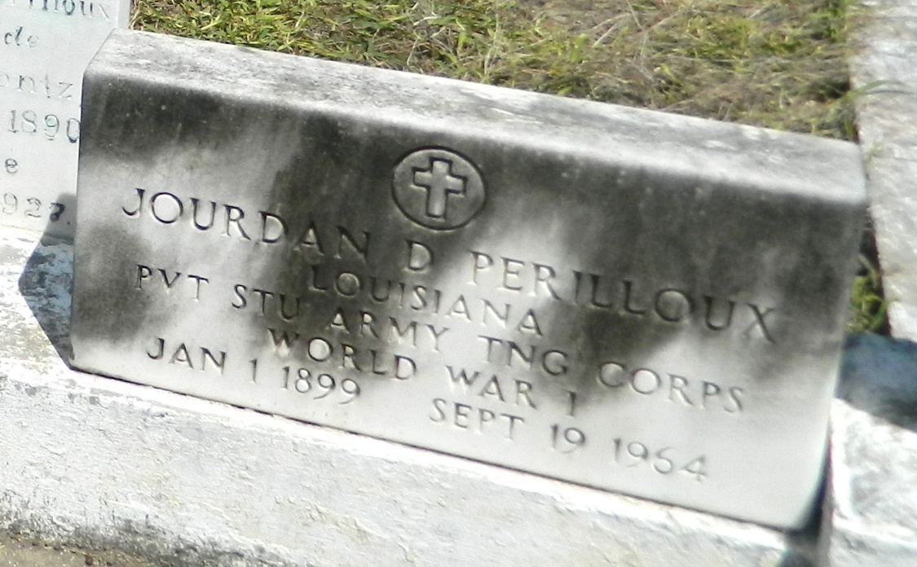

Jourdan D Perilloux Jr, a resident of Laplace, Louisiana, died Saturday 19 Sep 1964 at 12:40 p.m. at age 65 years.
He was the husband of Denise Millet and the father of J D Perilloux III and Mrs. Yvonne Aucoin both of Laplace, Mrs. Kathleen Elstrott of Metairie, Louisiana, Mrs. Evelyn Hare of New Orleans, Mrs. Ida Nobles of Houma, Louisiana, Mrs. June Maurin and Mrs. Marguerite Trussell Jr of Michigan. He was the son of the late Jourdan D Perilloux Sr and Ida Montz and the brother of Charles and Paul Perilloux. Also survived by 16 grandchildren.
Services were Monday 21 Sep 1964 at St Joan of Arc Church, Laplace, with interment in St Peter Cemetery, Reserve, Louisiana.
The Times-Picayune, New Orleans, Louisiana
20 Sep 1964

