Judy Ann (Perret) Perilloux

April 5, 1937 - April 10, 2024

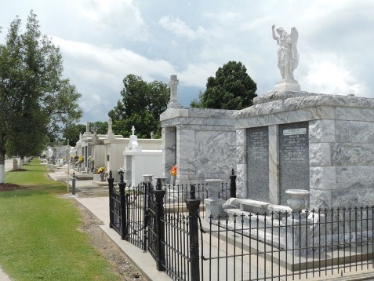

Judy Ann Perret Perilloux passed away on Wednesday, April 10, 2024 at the age of 87. She was born in New Orleans and was a longtime resident of LaPlace. Judy was a graduate of Soule Business College. She was employed with the Bank of St. John in LaPlace and later retired from Sears Retail Center in LaPlace. Judy was a parishioner of St. Joan of Arc Catholic Church where she was a member of their choir for over 40 years and a member of the Ladies Altar Society.
Judy’s greatest passion besides her children was her love for quilting. She gifted a quilt for each of her children, grandchildren and great-grandchild-ren. Judy also loved her flower garden.
Beloved wife of 66 years to Leonard “Cream” Perilloux. Loving mother of Mary Kim Arcuri (Jay), Julie Songy (Joey), Lauren Sulik (the late Alex Sulik, Jr.), and Jason Perilloux (Tracy). Grandmother of Jeremy (Maria), Katie (Anthony), Abby (Jeremy), Jarett (Nicole), Luke (Misty), Kristina, Kelsey, and Chloe. Great-grandmother of Avery, Elijah, Isaiah, Isla, Aiden, Zoey, and Kade. Daughter of the late Leonie Haydel and Henry P. Perret, Jr. Sister of Karen Coleman (the late Charles). Also survived by nieces and nephews.
Relatives and friends are invited to attend the Funeral Service at St. Joan of Arc Catholic Church, 529 W. 5th St., LaPlace on Monday, April 15, 2024. Visitation will begin in church at 10:00 a.m. with the Funeral Mass to immediately follow at 12:00 p.m. Interment in St. Peter Cemetery, Reserve.

Millet-Guidry Funeral Home, LaPlace, Louisiana
April 12, 2024

