Julia (Desroche) Perilloux
July 1, 1876 – January 31, 1953

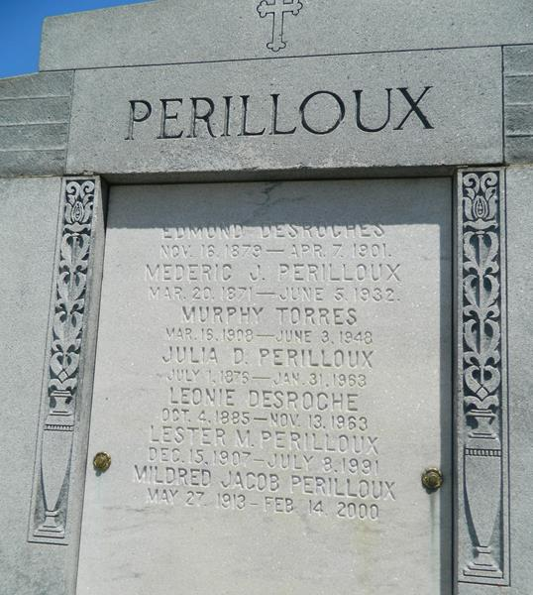

Funeral services were held for Mrs. Mederic Perilloux, 86 years old, a widely known resident of St. John the Baptist parish. She died on January 31 at the home of her youngest daughter, Mrs. A. J. Frederic, in Reserve, LA, where she had been living during the past several months. Mrs. Perilloux died in her sleep on Thursday morning, January 31.
The former Julia DesRoche, Mrs. Perilloux married the late Mederic Joseph Perilloux of Lions, La., in 1894. The Perilloux family moved to Laplace in 1898. Mrs. Perilloux was born on July 1, 1876, at Lions, LA.
Services for Mrs. Perilloux were held from the Millet Funeral Home in Reserve on February 2. and interment was in the family tomb in St. Peter cemetery in Reserve.
Mrs. Perilloux is survived by five sons, Lucien, Clarence, Claude and Roy Perilloux of Detroit, Mich., and Lester Perilloux of Laplace, and by four daughters, Mrs. Joseph E. Meyer, Mrs. Chester Wicker, Mrs. Harry C. Meyer, Jr., all of New Orleans, and Mrs. Frederic of Reserve. She is survived by one sister, Miss Leonie DesRoche. Mrs. Perilloux is survived also by 26 grand-children and 29 great-grandchildren.
L'Observateur, LaPlace, Louisiana
Thursday, 7 Feb 1963, p. 6

