Lawrence James Perilloux
September 14, 1893 - October 13, 1969

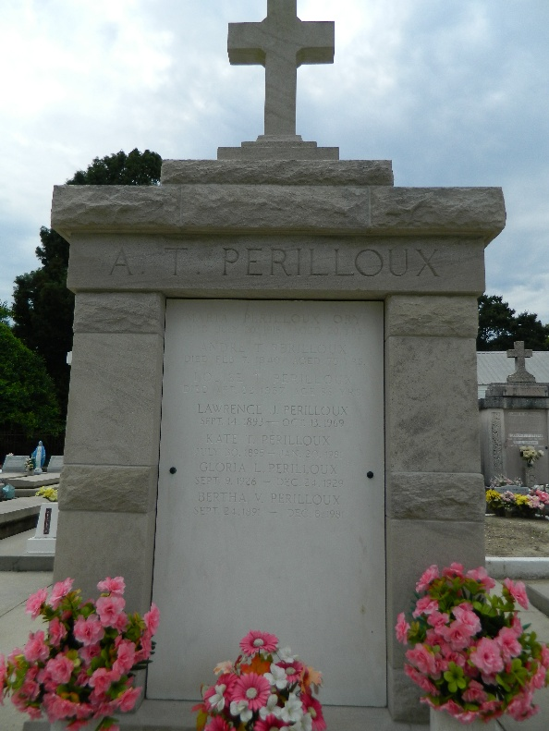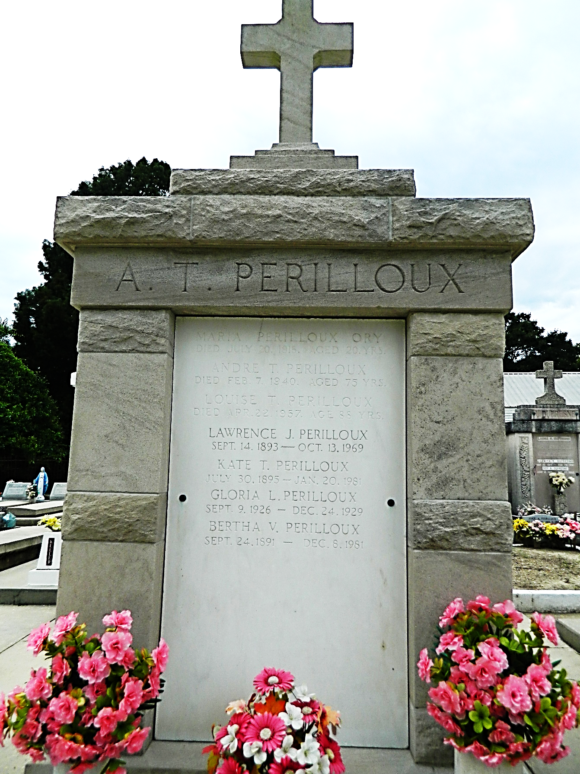

Lawrence J (Lois) Perilloux died Monday, 13 Oct 1969 at 3:20 p.m. at age 76 years. He was a native of Reserve, Louisiana, a former resident of Laplace, Louisiana, and a resident of Reserve for the past 7 months.

He was the husband of Kate Tamplain and the father of Mrs. Carl Leslie Levet and Mrs. Albert (Billy) Luminais of Reserve. He was the brother of Henry Perilloux of Laplace, Mrs. Emile Hotard and Miss Bertha Perilloux of Reserve. Also survived by 10 grandchildren and one great-grandchild.

Services were Wednesday, 15 Oct 1969 at St Peter Church, Reserve, with interment in St Peter Cemetery, Reserve.
The Times-Picayune, New Orleans, Louisiana
14 Oct 1969

