Leontine (Roubleau) Perilloux
February 24, 1906 – June 26, 1986

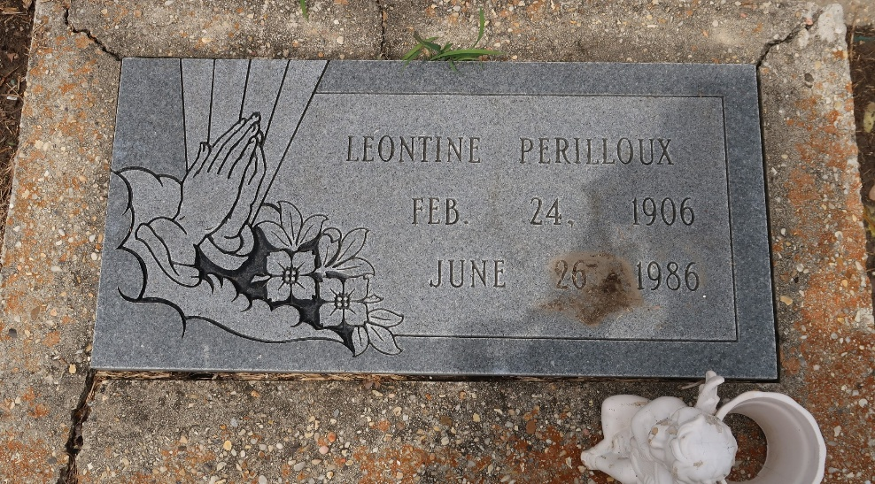

Leontine Perilloux died Thursday 26 Jun 1986 at 5:00 pm at age 80 years.

She was a native and resident of Laplace, Louisiana, and the wife of the late Louis Perilloux. Mother of Ethel Wempren and the late Rudolph Perilloux. She was the sister of Josephine Vicknair, Ora Reed, Leona Guilbeau and Earline Branch. Also survived by 6 grandchildren, 12 great-grandchildren and 4 great-great-grandchildren.

Services were Monday 30 Jun 1986 at St Joan of Arc Catholic Church, Laplace, with interment in St Peter Cemetery, Reserve, Louisiana.
The Times-Picayune, New Orleans, Louisiana
June 30, 1986

