Lester Mederic Perilloux
December 15, 1907 – July 8, 1991

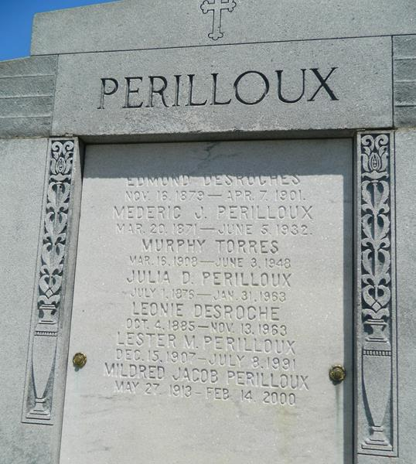

Lester M Perilloux, a native and resident of Laplace, Louisiana, died Monday, 8 Jun 1991 at 3 p.m. at age 83 years.
He was the husband of Mildred J Perilloux and the father of Gerald (Cosmo) and Bruce Perilloux, Sandra P Pounds and the late Lester (Dee Dee) Perilloux Jr. He was the son of the late Julia D and Mederic Perilloux and the brother of Denise Wicker, Marion Frederic and the late Juliet and Helen Meyer, Lucien, Clarence, Claude and Roy Perilloux. Also survived by 13 grandchildren and 12 great-grandchildren.
Services were Thursday 11 Jul 1991 with interment in St Peter Cemetery, Reserve, Louisiana.
The Times-Picayune, New Orleans, Louisiana
July 10, 1991

