Louis Perilloux

January 16, 1899 – November 1, 1965

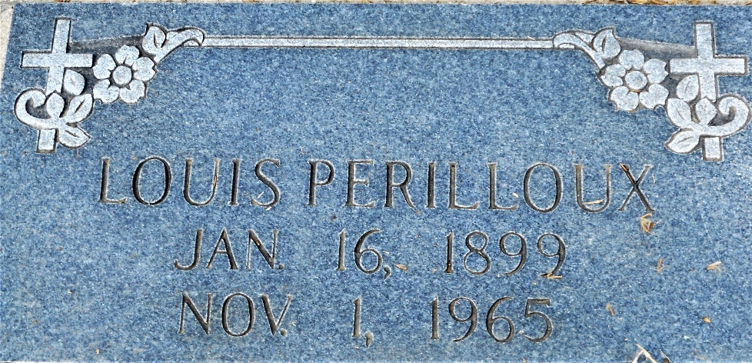

Photo by Team T-Lo

Son of Felix Perilloux and Ernestine Schexnayder. Age 66 years at death, a native and resident of Laplace, LA.

Husband of Leontine Roubleau and father of Mrs. Claude Wempren and Rudolph Perilloux of Laplace. Six grandchildren and four great-grandchildren.

Funeral services Tuesday 2 Nov 1965 at St Joan of Arc Church, Laplace, with interment in St Peter Cemetery, Reserve, LA.

The Times-Picayune, New Orleans, Louisiana

November 2, 1965