Louise Appline (Tregre) Perilloux
November 27, 1868 – April 22, 1957

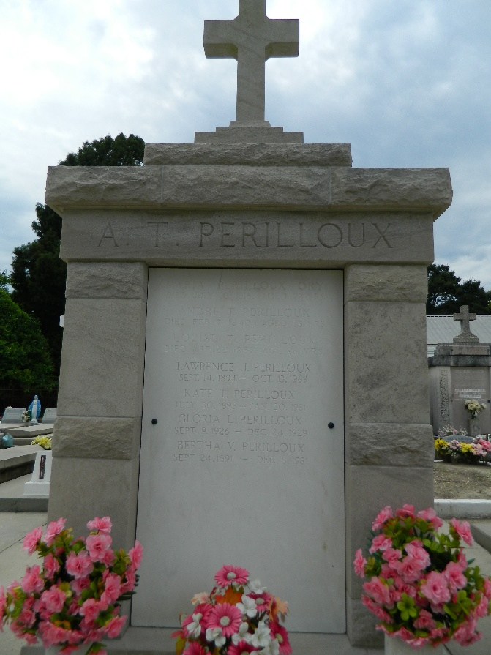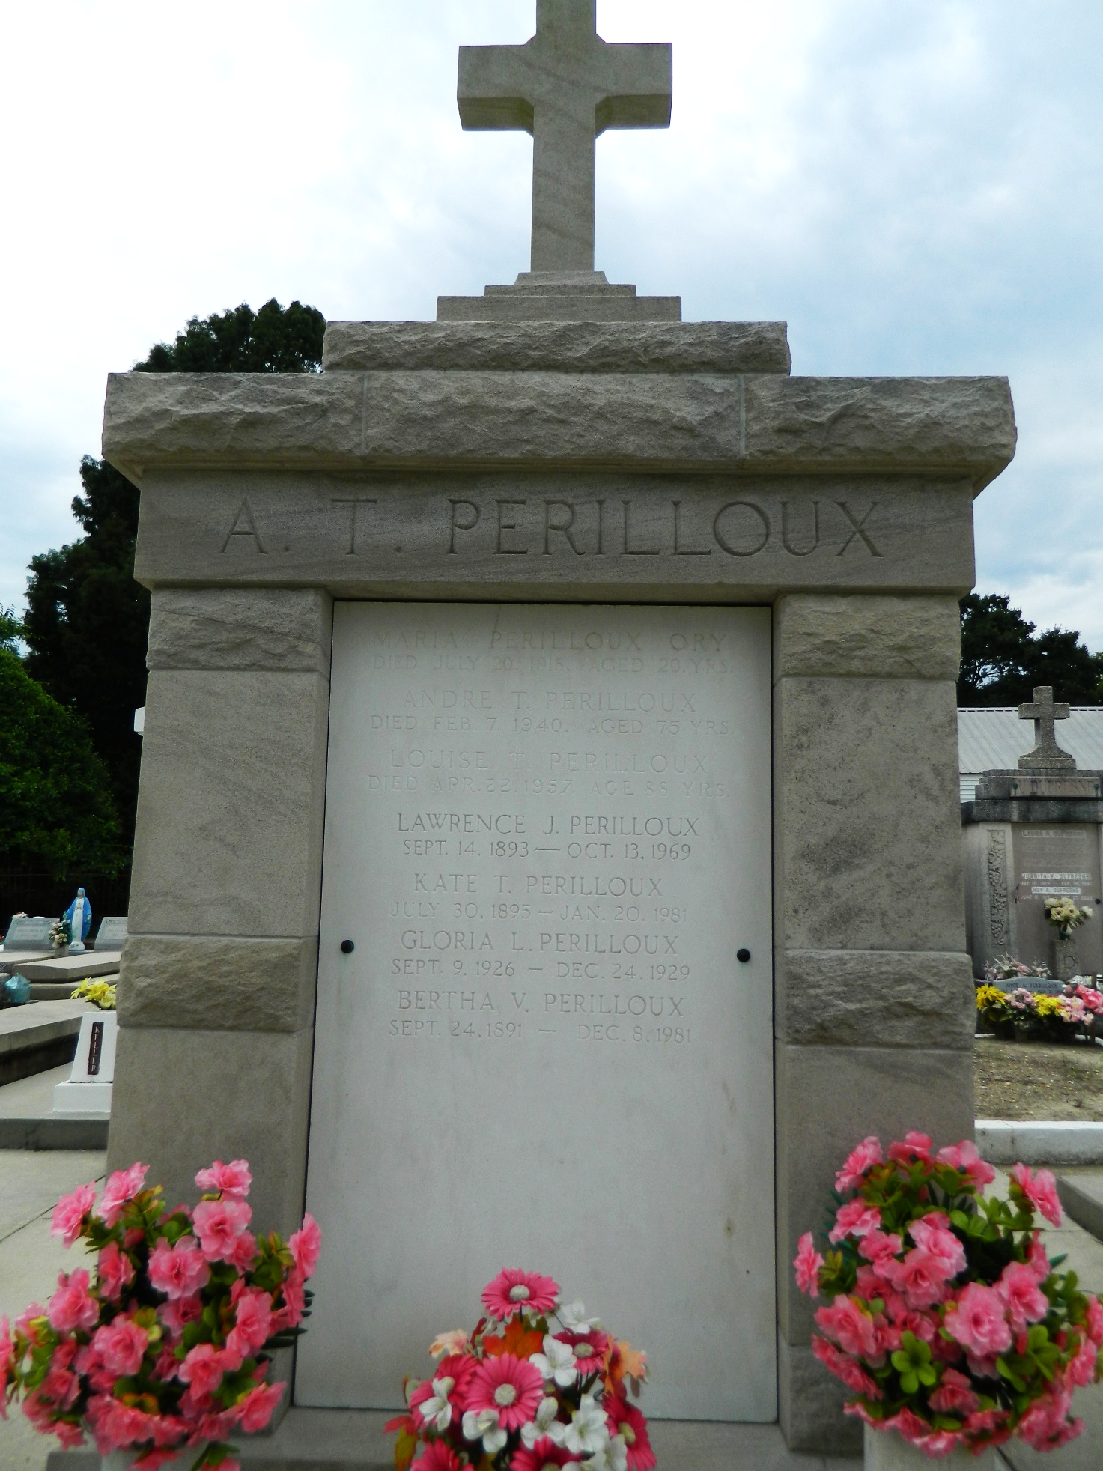

Louise A Tregre, wife of the late Andre T Perilloux, died at her residence in Laplace, Louisiana, on Monday, 22 Apr 1957 at 2:30 a.m. at age 88 years and 5 months.
She was the mother of Mrs. Emile Hotard of Reserve, Louisiana, and Bertha, Lawrence and Henry Perilloux of Laplace, and the late Maria Perilloux Ory. Also survived by four grandchildren and nine great-grandchildren.
Services were Tuesday 23 Apr 1957 at St Peter Church, Reserve, with interment in St Peter Cemetery, Reserve.
The Times-Picayune, New Orleans, Louisiana
23 Apr 1957

