Marie Louise (Madere) Perilloux

June 16, 1857 – December 1, 1942

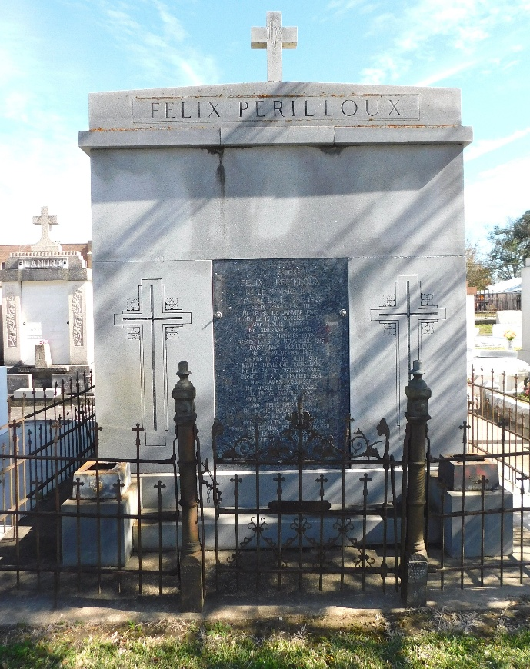 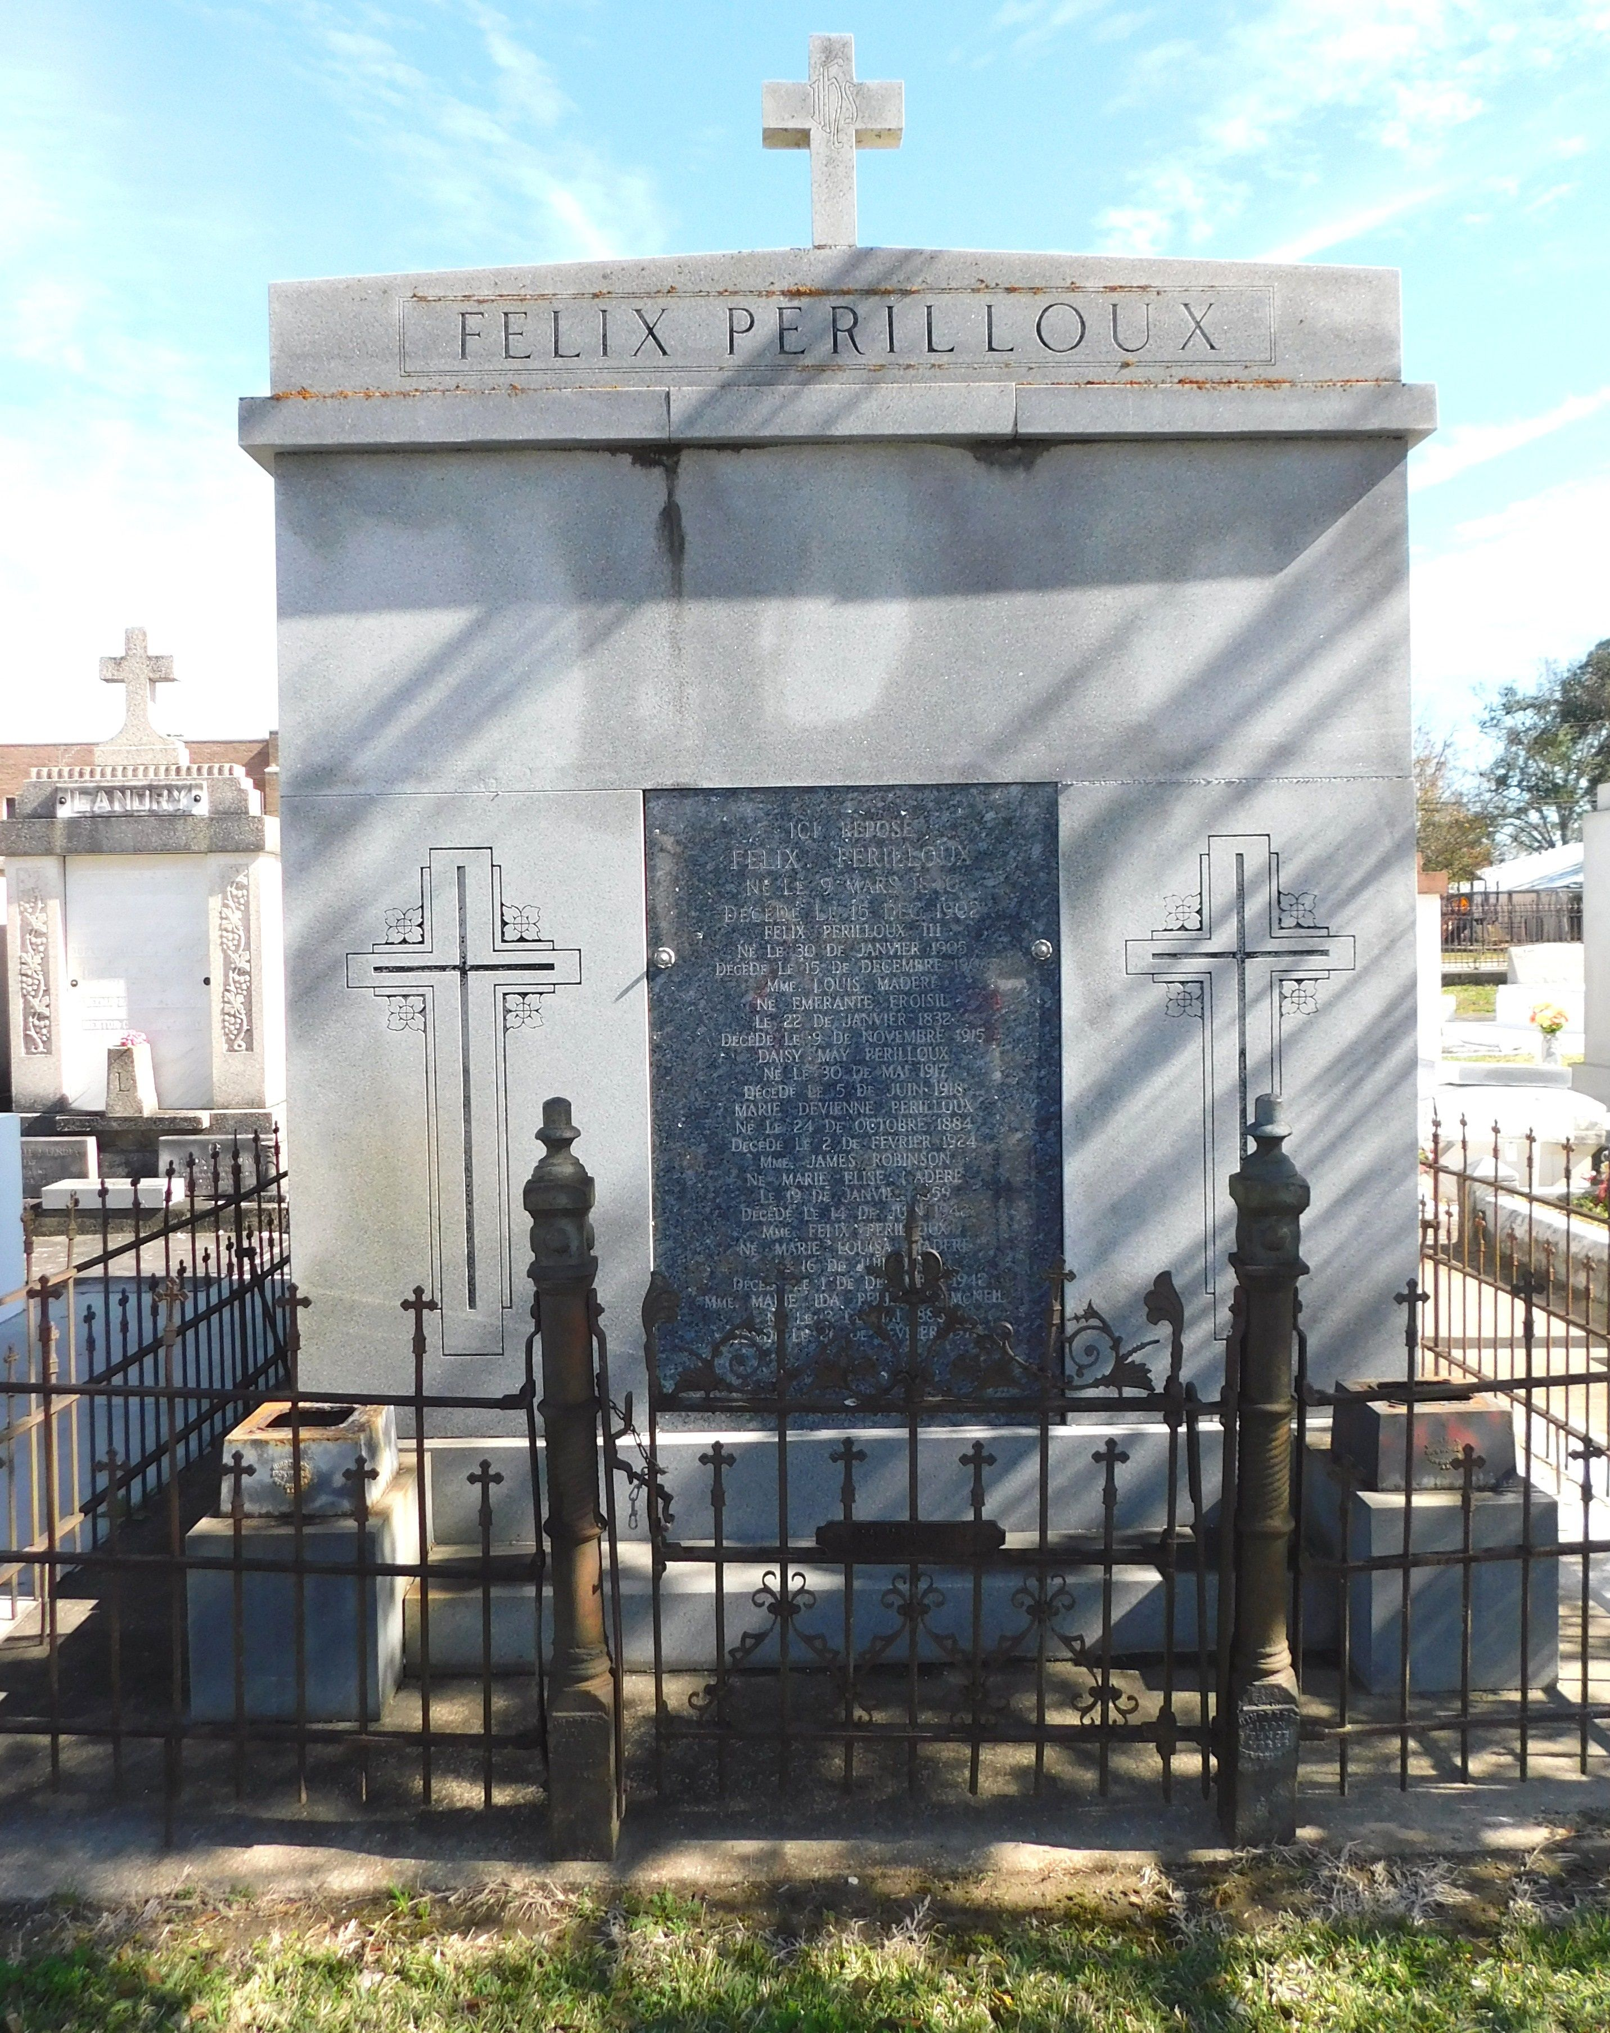

Photos by Mary Agness Hammett

PERILLOUX-On Tuesday, December 1, 1942, at 3:45 o'clock a.m., at the residence of her son-in-law, Charles L McNeil, 8611 Oak street, New Orleans, La, LOUISE MADERE, widow of the late Felix Perilloux, mother of Mrs. Ida Perilloux McNeil of New Orleans, Zerphirin and Joseph Perilloux of Montz, La, stepmother of Mrs. Albert Millet of Lions, La, Mrs. A Gailard of New Orleans, La, sister of Mrs. F. Bildstein of New Orleans, also survived by a number of grandchildren and great grandchildren, aged 86 years, a native of St John parish and a resident of Montz, La, for 43 years.

Relatives and friends of the family are respectfully invited to attend the funeral, which will take place from the Jules Millet Funeral Home, Reserve, La, on Wednesday, December 2, 1942, at 9:30 o'clock a.m. Requiem mass at St Peter church, Reserve, La. Interment in St Peter cemetery.

The Times-Picayune, New Orleans, Louisiana

December 2, 1942, p. 2