Mederic Joseph Perilloux
March 26, 1872 – June 5, 1932

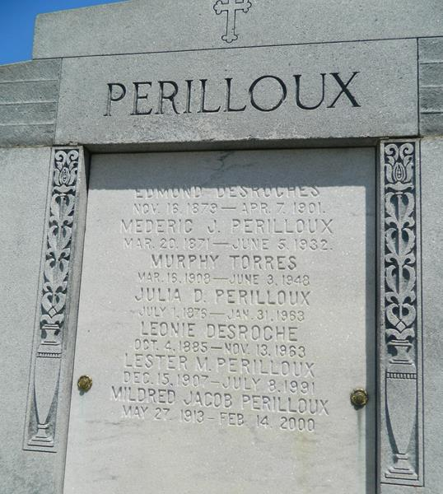

Mederic J. Perilloux of Laplace, Louisiana, died Sunday, 5 Jun 1932 at 7:40 pm in his 61st year of age.

He was the husband of Julia Desroches and the father of Lucien, Clarence, Claude, Juliet, Lester, Denise, Roy, Helen and Marion Perilloux.

Services were Monday, 6 Jun 1932 at St Peter Church, Reserve, Louisiana, with interment in St Peter Cemetery, Reserve.

The Times-Picayune, New Orleans, Louisiana
June 7, 1932
Contributed by Dwayne Montz

NOTE: St Peter Church records, Baptism Book 1, p 146, list his birth as 26 Mar 1872 with baptism on 24 Apr 1872.

