Shirley (Vicknair) Perilloux
September 20, 1925 – January 11, 2022

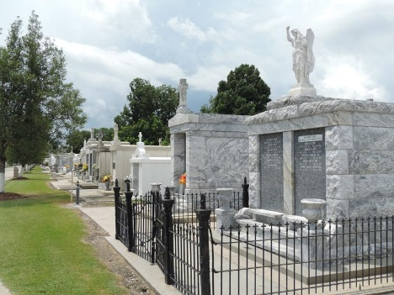
Shirley Vicknair Perilloux passed away on Tuesday, January 11, 2022 at the age of 96. She was a native and a resident of Montz, LA.
Beloved wife of Arthur Perilloux. Loving mother of Karen Schumacher (Hank) Todd Perilloux and the late Sharon Simmoneaux and Artie Perilloux. Grandmother of Dan Taillon (Colette), Jeffrey Simmoneaux (Christy), Tiffany Simoneaux (Bobby), Cassidy Perilloux, Blake Perilloux, Alli Perilloux, Joseph Perilloux, Trista Phillips (Sean), Matt Schumacher (Andre), Terri Martin (Beau), and Adam Schumacher (Kelly). Great grandmother of Dusty Taillon, Lane Taillon, Ty Taillon, Anabella Simoneaux, Sophia Simoneaux, and Luke Simoneaux. Great, Great Grandmother to Elma “Elena” Taillon. Daughter of the late Louis and Denise Vicknair. Also survived by numerous nieces and nephews.
Shirley was a very humble woman with a heart of gold. One of her greatest fulfilments in life was helping others and spending time with her family and friends. The love she portrayed toward her family and friends was an unconditional love and it showed in everything she did. She spent countless hours helping her children, grandchildren, or anyone that needed her. Everything she did was done to perfection.
There wasn’t a person on this Earth that could cook or clean like Shirley. In her earlier days she enjoyed working at the St. Joan of Arc Thrift Shop, having potluck dinners, playing poker and going on bus tours with her friends. She had a love for life like no one else. Her legacy and love will live on in our hearts forever.
Services were held on Friday January 14th, 2022. Arrangements by Millet-Guidry Funeral Home

L'Observateur.com
January 17, 2022

