Vivian Marie (Cambre) Perilloux

February 2, 1894 – March 23, 1985

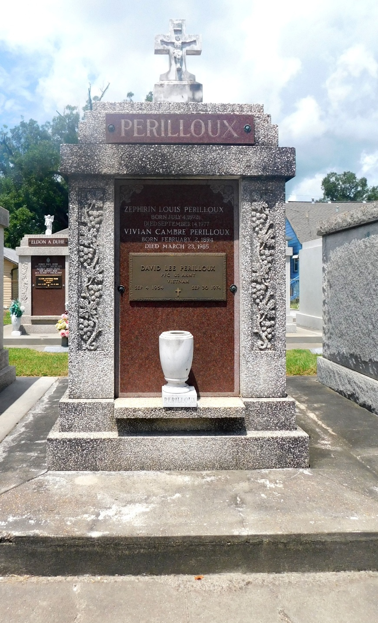

Mrs. Vivian Cambre Perilloux, a native of Lions, Louisiana, died at her daughter's home in Metairie, Louisiana, on Saturday, 23 Mar 1985, at age 91 years.

Mrs. Perilloux was president of the Montz Elementary School Parent Teachers's Organization for 18 years and was a member of the St Charles Borremeo and Destrehan High School PTAs. She was a social columnist for the St Charles Herald for 25 years and worked for the U.S. Coast Guard as a Mississippi River light tender for 15 years. During World War II, Mrs. Perilloux was active in the Red Cross. She was a member of the Catholic Daughters of America, the Court Joan of Arc, and the St Isadore, St Joan of Arc and Sacred Heart Alter societies.

L'Observateur, LaPlace, Louisiana

March 25, 1985