Zoe (Vicknair) Perilloux
Jul7 31, 1889 – May 5, 1981

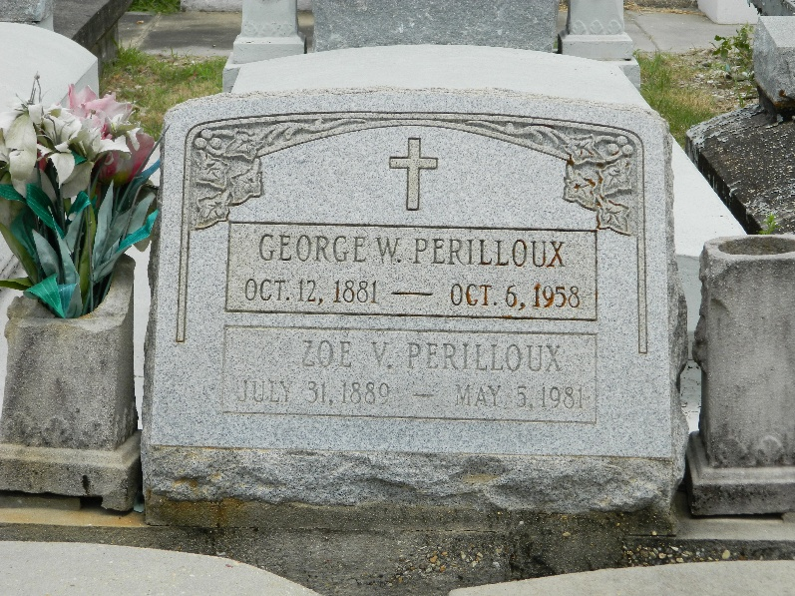

Zoe Vicknair Perilloux, wife of the late George Perilloux, died Tuesday 5 May 1981. She was a native of Laplace, Louisiana, and a resident of Reserve, Louisiana.

She was the daughter of the late Caroline Vicknair and Joseph Vicknair and the sister of the late Denise Madere, Leah Triche, Lucy DeLaneuville and August Vicknair.

Services were Thursday 7 May 1981 at St Peter Church, Reserve, with interment in St Peter Cemetery, Reserve.
The Times-Picayune, New Orleans, Louisiana
May 6, 1981

