Beulah (Amedee) Perret
August 19, 1913 – January 16, 2007

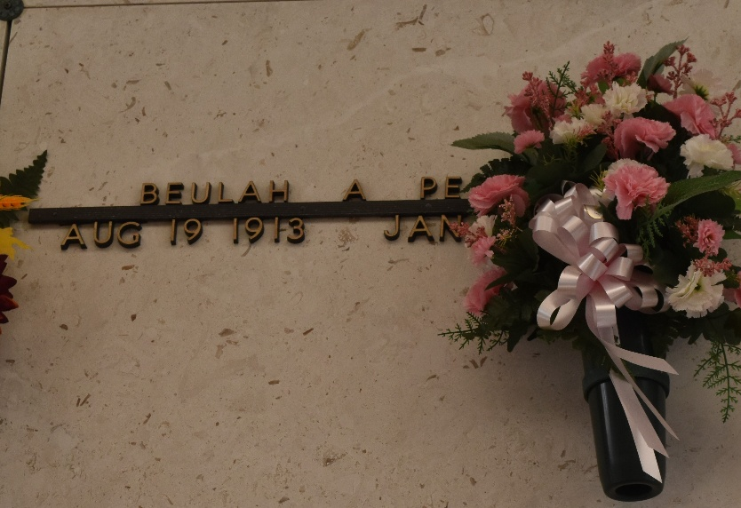

Beulah Amedee Perret, On Tuesday, January 16, 2007 At 6 Am.
Beloved Wife Of The Late William Perret, Sr. Mother And Mother-In-Law Of William, Jr. And Joycelyn Jacob Perret And Carl And Frances Schexnayder Perret. Daughter Of The Late Adolphe And Louise Amedee. Sister Of C.J. Amedee, Marie Barrios And The Late Bert Amedee And Winnie Zeringue. Also Survived By 8 Grandchildren And 18 Great-Grandchildren. Age 93. A Native Of Vacherie And A Resident Of Reserve For The Past 70 Years.
Relatives And Friends Of The Family, Also St. Peter Ladies Altar Society Are Invited To Attend Services. Visitation At St. Peter Catholic Church, Reserve On Thursday, January 18, 2007 From 10 Am To 12 Noon. Followed By Religious Services At The Church At 12 Noon. Burial In Church Cemetery. Arrangements By Millet-Guidry Funeral Home, Laplace.

The Times-Picayune, New Orleans, Louisiana
January 17, 2007

