Sybyl (Joffrion) Perret

November 15, 1916 – February 10, 2008

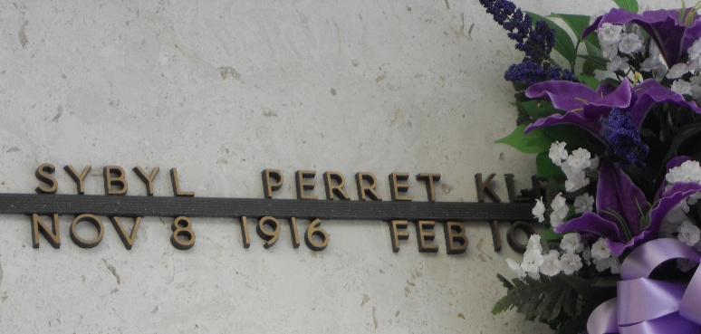

Photo by Team T-Lo

Sybyl (Lady) Klibert Perret on Sunday, February 10, 2008 at 12:31 AM. Beloved wife of the late Henry Perret and by first marriage of the late Hewitt (Ape) Klibert. Mother and mother-in-law of Gwen and Gene Delaneuville and Sybil and Ken Simon. Grandmother of Lori Poirrier, Lisa Bergeron, Scott Delaneuville, Todd, Gregg and Bruce Simon and Stacy Vicknair. Great-grandmother of Cory, Ashley, Brett, John Paul, Jeremy, Nicole, Matthew, Jamie, Kaci, Austin, Ryan and Katie. Great-great-grandmother of Matelyn. Sister of Beryl Considine and the late Harold and Pappy Joffrion, Mildred Villmont, Lillian Bayer and Wanda Bullard.

Special thanks to Riverlands Health Care and St. Catherine's Hospice. Age 91 years, a native of Napoleonville, La. and a former resident of Reserve and a resident of Gramercy for the past 8 years.

Relatives and friends, also Catholic Daughters, American Legion Auxiliary, K.C.A. and Ladies Altar Society are invited to attend services. Visitation at St. Peter Catholic Church, Reserve, La. on Tuesday, February 12, 2008 from 12pm to 2pm. Followed by Religious Services at the church at 2pm. Burial in church. Arrangements by Millet-Guidry L.L.C. Funeral Home, LaPlace, La.

The Times-Picayune, New Orleans, Louisiana

Feb. 11, 2008