William Francis Perret Jr.
February 8, 1935 – April 4, 2015

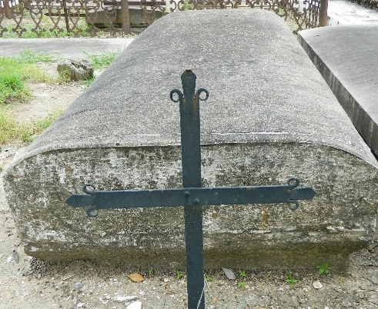

William “Billy” Francis Perret, Jr. passed away on Saturday, April 4, 2015 at the age of 80. Retired employee of 26 years from E I Dupont.
Beloved husband of 55 years to Joycelyn Jacob Perret. Loving father of Rachelle Graham (Michael), Vicki Bollich (Matthew Scott), Gregory Perret (Julia) and Craig Perret (Dawn). Grandfather of Brandi Graham Bacigalupi (Bart), Jennifer Graham Sison (Michael) and Angelle Graham, Wesley, Austin and Connor Bollich, Matthew, Jonathan and Luke Perret, Jacob, Blaine and Noah Perret. Great grandfather of Sophia and Graham Bacigalupi. He is also survived by his brother, Carl Perret (Frances), sisters-in-law, Jackie Roussel and Linda Jacob, numerous nieces, nephews, friends and neighbors.
He was preceded in death by his parents, William and Beulah Amedee Perret and brothers-in-law, Jessie Roussel and Malcolm Jacob.
The family would like to give special thanks to the staff of Ochsner Extended Care and Metropolitan Dialysis Center.
Relatives and friends are invited to attend the visitation at Millet-Guidry Funeral Home, 2806 W. Airline Hwy, LaPlace on Wednesday, April 8, 2015 from 5:00 p.m. to 8:00 p.m. and on Thursday, April 9, 2015 from 9:30 to 10:30 a.m. The Funeral Mass will follow at St. Peter Catholic Church, 1550 Hwy 44, Reserve at 11:00 a.m. Interment in St. Peter Cemetery.
In lieu of flowers, the family request donations be made in his memory to St. Peter’s Catholic School.

Millet Guidry Funeral Home, LaPlace, Louisiana

