Anderson Perrilloux Sr.

September 3, 1928 – October 2, 2009

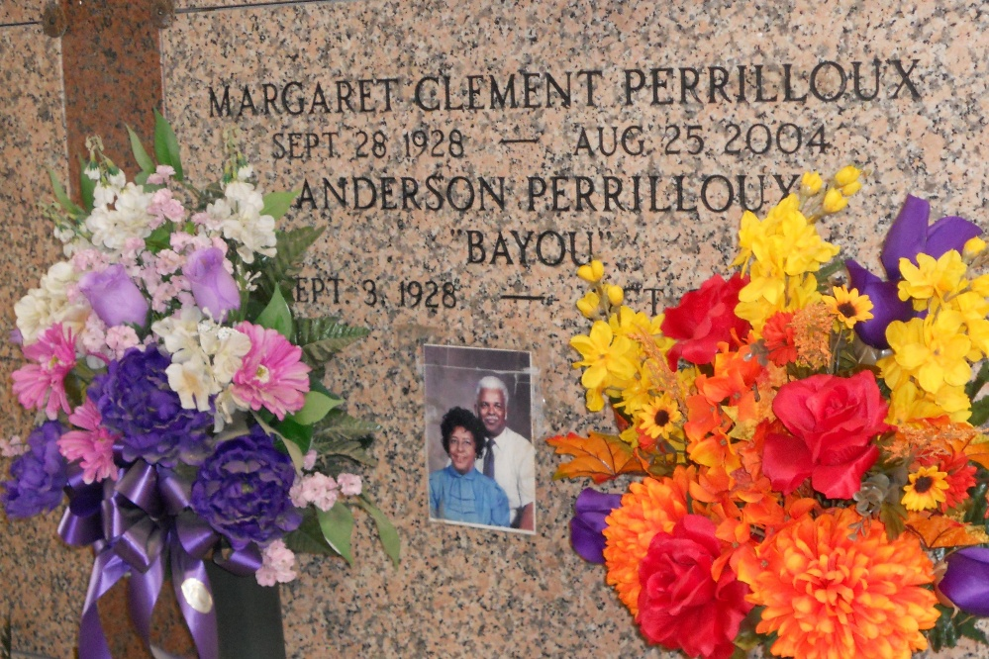

Photo by Team T-Lo

Anderson "Bayou" Perrilloux, Sr. on Friday, October 2, 2009.

Son of the late Elizabeth Cook and Edward Perrilloux. Beloved husband of the late Margaret C. Perrilloux. Father of Lois P. Frank, Anderson, Jr. (Indria), Burnell, Sr. (Diane), and Wayne Perrilloux, Marilyn Scott (Vergil), Manuel King, and the late Wendell Morris. Brother of Mavis Fobb, Richard Perrilloux, Elliott Cook, Norman Weston, the late Donna Jean P. Kendrick, Verna Cosey, Leatrice Young, Ferdinand and Edwin Perrilloux. Also survived by 32 grandchildren, a host of great grandchildren, nieces, nephews, other relatives and friends. Age 81 years. A native and resident of Reserve, LA.

Relatives and friends of the family, also priest and parishioners of Our Lady of Grace Catholic Church, pastors, officers and members of Pleasant Hill Baptist Church of Romeville, LA and all neighboring churches, former employees of Godchaux Henderson Sugar Refinery and employees of St. John the Baptist Parish School Board, Cajun Contractors, Chicago Transit Authority, Tara High School, and The Printing Source are invited to attend the Mass of Christian Burial at Our Lady of Grace Catholic Church, 772 Highway 44, Reserve, LA on Thursday, October 8, 2009 at 11:00 AM. Father Joseph Rodney, Celebrant. Interment St Peter Cemetery, Reserve, LA. Visitation at Robottom Mortuary, 850 Highway 44, Reserve, Louisiana on Wednesday evening, October 7, 2009 from 4:30 PM until 7:00PM and at the above named church on Thursday morning, October 8, 2009 from 9:00 AM until Mass time. Rosary at 10:00 a.m. SERVICED BY ROBOTTOM

The Times-Picayune, New Orleans, Louisiana

Oct. 7, 2009