Anita (Cureaux) Perrilloux
December 1936 – September 22, 2017

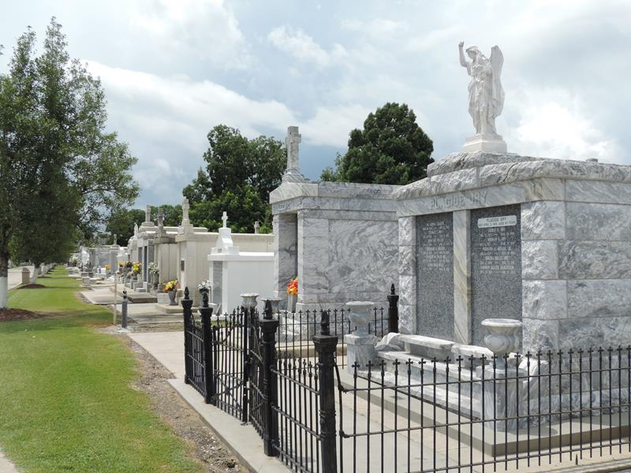

Anita Cureaux Lennix Perrilloux on Friday, September 22, 2017 at her home in Reserve, LA.
Daughter of the late Florence Berkeley and Ernest Cureaux, Sr. Wife of the late Lowery Leroy Lennix, Sr. by first marriage and Curtis Lee Perrilloux, Sr. by second marriage. Mother of Lowery Lennix, Jr. (Angela), Andre Lennix (Nikita), Roslyn Joseph (Robert, Sr.), Chriselle Henry (Kerry, Sr.), Sharnell Reid (Clyde), Raynette Lennix and Raynelle Lennix (Diredre). Stepmother of Curtis Perrilloux, Jr. (Naomi), Danielle Young (Anthony) and the late Brian Perrilloux. Sister of Paul Cureaux, the late Vivian Ellis, Nita Cureaux, Sedonia Frederick, Ernest Cureaux, Jr., Willie Cureaux, Sr. and Theresa Duhe. Sister-in-law of Evelyn Mitchell, Wanda Calais (Charlie), Judy Green (Jimmie), Elmore Perrilloux, Sr. (Annie) and Keith Perrilloux (Minerva). Also survived by 22 grandchildren, 14 great grandchildren and a host of nieces, nephews, cousins, other relatives and friends. Age 80 years. A native of Garyville, LA and a resident of Reserve, LA.
Relatives and friends of the family, also priest and parishioners of Our Lady of Grace Catholic Church and all neighboring churches are invited to attend the Funeral Mass at Our Lady of Grace Catholic Church, 772 Hwy 44 (River Road), Reserve, LA on Saturday, September 30, 2017 at 10:00 AM. Father Christopher Amadi, Celebrant. Interment St. Peter Cemetery, Reserve, LA. Visitation at the above named church from 8:15 AM until Mass time. Rosary at 9:15 AM.
SERVICED BY ROBOTTOM

The Times-Picayune, New Orleans, Louisiana
September 29, 2017

