Audrey Theresa (Gravois) Perrilloux

June 25, 1928 – March 9, 2023

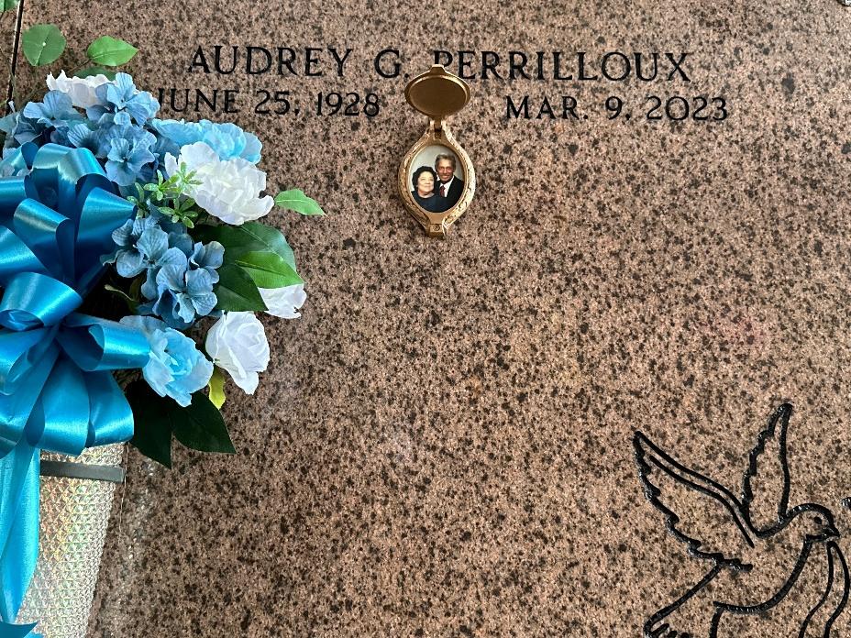

Audrey Theresa Gravois Perrilloux, transitioned to her heavenly home on Thursday, March 9, 2023, at her home in Reserve, LA.

Daughter of the late Oneda Gaudin Gravois and William B. "Willie" Gravois of Union, LA. Wife of the late Noland Joseph Perrilloux, Sr. Mother of Clinton J. Perrilloux, Sr. (Donna), Darryl M. Perrilloux, Sr. (Charmaine), Charmaine A. Perrilloux and Noland J. Perrilloux, Jr. (Lisa). Also survived by 10 grandchildren, 17 great grandchildren, 10 great-great grandchildren and a host of nieces, nephews, cousins, other relatives and friends. A native of Union, LA and a resident of Reserve, LA for over 74 years.

Relatives and friends of the family, also priest and parishioners of Our Lady of Grace Catholic Church and all neighboring churches are invited to attend the Funeral Mass at Our Lady of Grace Catholic Church, 772 Hwy 44 (River Road), Reserve, LA. on Saturday, March 18, 2023, at 11:00 AM. Rev. Godwin Ani, SSJ, Celebrant. Visitation at the above-named church from 8:15 a.m. until Mass time. Interment at St. Peter Catholic Church Cemetery.

Serviced By Robottom Mortuary.

Published by Legacy Remembers on Mar. 17, 2023