Celeste (Trepagnier) Perrilloux
September 15, 1924 – May 25, 2014

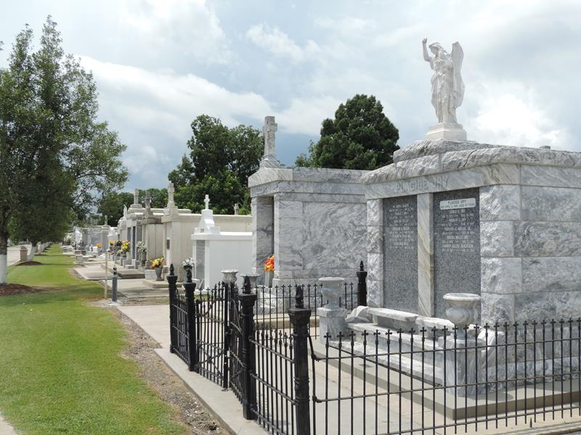

CELESTE T. PERRILLOUX on Sunday, May 25, 2014 at her home in Reserve, LA.
Daughter of the late Mary Turcuit and Sheridan Trepagnier. Wife of Clarence "Blackhead" Perrilloux, Jr. Mother of Clive (Samuel) Brown, Sylvia (John) Clayton, Dwight (Debbie) Perrilloux, Sr., Steven (Rita) Perrilloux, Sr. and the late Jeffery Perrilloux. Sister of the late Wilma Trepagnier, Sheridan Trepagnier, Jr., Francis T. Washington, Pearl T. Pierre, Alvis T. Winchester, Dennis Trepagnier, Marion T. Cantrell and Iola T. Brooks. Also survived by 43 grandchildren, 23 great grandchildren and a host of nieces, nephews, other relatives and friends. Age 89 years. A native St James, LA and resident of Reserve, LA.
Relatives and friends of the family, also priest and parishioners of Our Lady of Grace Catholic Church and all neighboring churches are invited to attend the Funeral Mass at Our Lady of Grace Catholic Church, 772 Highway 44, Reserve, LA on Saturday, May 31, 2014 at 10:00 AM. Father Christopher Amadi, Pastor. Fr. Joseph Rodney, Celebrant. Interment St. Peter Cemetery, Reserve, LA. Visitation at the above named church from 8:15 AM until Mass time. Recitation of the rosary at 9:15 AM.
SERVICED BY ROBOTTOM

The Times-Picayune, New Orleans, Louisiana
May 28 to May 30, 2014

