Clarence J. Perrilloux Jr.
August 5, 1925 – September 2, 2014

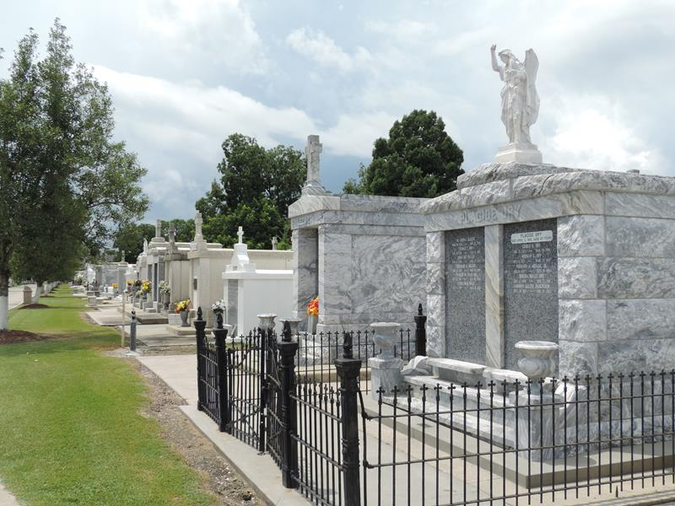

Clarence J. Perrilloux departed on Tuesday, September 2, 2014, at the age of 89 years old.
Son of the late Harriet and Clarence Perrilloux Sr. Husband of the late of Celeste T. Perrilloux. Father of Clive (Samuel) Brown, Sylvia (John) Clayton, Dwight (Debbie) Perrilloux, Steven (Rita) Perrilloux Sr, the late Jeffery Perrilloux, and Lyntrell Pitts. Brother of Rita Dents, the late Lydia Perrilloux and Pauline Miller. Also survived by 25 grandchildren, and 45 great grandchildren and a host of nieces, nephews, other relatives and friends.
Relatives and friends of the family are invited to attend the viewing at The Baloney Funeral Home, LLC., 1905 W. Airline Hwy., Laplace,La. on Friday, September 5, 2014, from 2:00 p.m. Until 7:00 p.m. Funeral services will be held at Riverlands Christian Center, 123 Redemption Way, Reserve, La., September 6, 2014 for 11:00 a.m. Viewing is from 9:00 a.m. until time of service. Pastor Steve Perrilloux will be officiating. Interment will be at St. Peter Cemetery in Reserve, La.
Funeral entrusted to The Baloney Funeral Home, LLC, 1905 W. Airline Highway, Laplace, La, 985-224-8460.

The New Orleans Advocate (LA)
Sep. 4 to Sep. 5, 2014

