Derrick Jude Perrilloux
August 10, 1961 – March 29, 2021

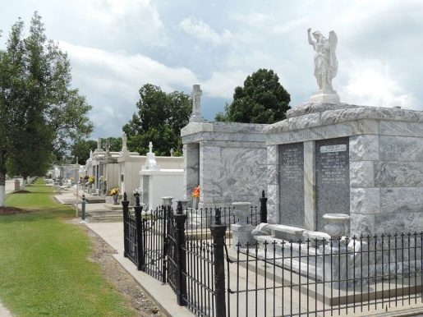

Derrick Jude "Spookie" Perrilloux departed this earthly life and entered eternal rest on March 29, 2021 at Our Lady of the Lake Hospital in Baton Rouge, LA.
Spookie, as he was affectionately known, was the third born child of Paul Perrilloux, Sr. and Ernestine Lee Batiste on August 10, 1961 in New Orleans, LA. Spookie leaves to cherish his memories, his children; Derrick (Chawana) Fleming, Sr., Juanita Fleming-Perrilloux, Harold (Crystal) Fleming, Sr., Ricketta Lee, and Chikita Lee; mother, Ernestine L. Batiste; step-father, Arizona Batiste; step-mother, Dorothy Perrilloux; siblings, Paul (Lisa) Perrilloux, Jr., Deborah Ann Marie (Sidney) Perrilloux-Cobbs, Stacy Rene' Michael Perrilloux, and Michael Paul Perrilloux; aunts, Ruthie Mae (Rev. Bobby) Turner, Jacklin (Burnell) Scott, Shynethia Parker; uncles, Calvin Lee, Warren Lee, Corey Lee, Nathan Lee, and Marvin Perrilloux; 14 grandchildren, 3 great -grandchildren, and a host of nieces, nephews, other relatives, and friends.
He was preceded in death by his father; Paul Perrilloux, Sr.; grandson, Amir Fleming; nephew, Jamal Jones; and uncles, Morris Lee, Jr., Michael Lee, and Marcel Perrilloux.
Family and friends are invited to the homegoing celebration on Tuesday, April 6, 2021 at 11 a.m. at The Historic Riverlands Christian Center, 123 Redemption Way, Reserve, LA 70084. Reverend Dr. Steven A. Perrilloux, Pastor. Visitation from 10 a.m. until service time. Interment: St. Peter's Cemetery, Reserve, LA. Viewing will be held on Monday, April 5, 2021 from 3 p.m. until 5 p.m. at Bardell's Mortuary, 3856 LA-44, Mt. Airy, LA 70076. Due to Covid 19, masks and social distancing will be enforced.
Services entrusted to Bardell's Mortuary. Information: (985) 535-6837.

The Times-Picayune, New Orleans, Louisiana
April 4-6, 2021

