Earline A. Perrilloux
February 3, 1930 – September 21, 2023

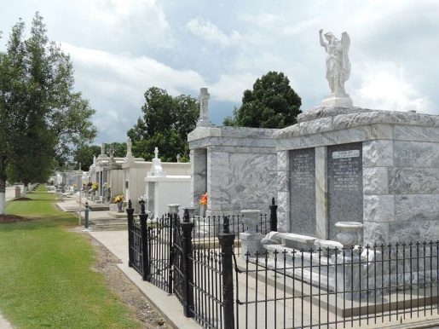

Earline A. Perrilloux departed this earthly life on Thursday, September 21st, 2023 at the age of 93.
She was the baby daughter of the late Remey J. Perrilloux, Sr. and Marguerite Keller Perrilloux. Sister to her late siblings Rodney, Louis, Remey Jr. and Noland Perrilloux Sr, Beatrice P. Jones, Marguerite P. Leche, Deborah and Geneva Perrilloux.
Earline was a seamstress for Deansgate Clothing Factory in New Orleans, LA for over 40 plus years. She leaves her memories to her nieces, nephews, cousins, friends and three godchildren.
Relatives and friends of the family are invited to attend the Funeral Mass of Christian burial on Saturday, September 30th, 2023 for 10:00am at Our Lady of Grace Roman Catholic Church, 722 Hwy 44, Reserve, LA 70084.
Visitation will start at 8:15am with the recitation of the rosary starting at 9:15am. Fr. Godwin Ani, SSJ officiating. Interment will follow at St Peter Cemetery, Reserve, LA.

Patrick H. Sanders Funeral Home & Funeral Directors, LaPlace, Louisiana

