Gaynelle Marie Perrilloux
April 12, 1968 – February 6, 2020

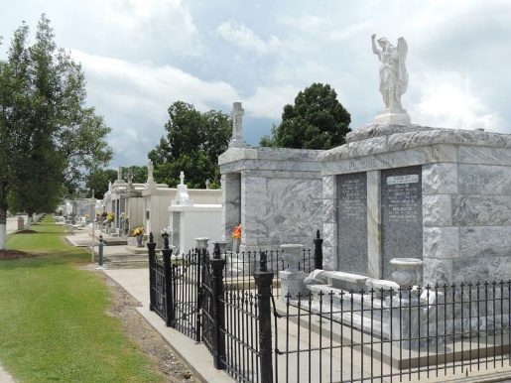

Gaynelle Marie Perrilloux, 51, of Laplace, LA passed away on February 6th, 2020 at Ochsner Main Campus in New Orleans, LA. Gaynelle was born April 12, 1968.
The loving wife to Lamar Ellis and mother to Marlon Jr, Jarrin, and Jasmin Perrilloux and the stepmother to Laniere Ellis. The daughter of Melvin (Miranda) Perrilloux Sr. and Cheryl Banks-Perrilloux and the sister of Melvin Perrilloux Jr, Dayna Perrilloux Mitchell, and Samantha Thomas. The loving grandmother to Ace, Jarrin Jr, Marlon III, and Malon Perrilloux, and step-grandmother to Dontae Morris. Gaynelle is survived by a host of loving Uncles, Aunts, Nieces, Nephews, Cousins, In-Laws, and Friends.
Gaynelle is preceded in death by her maternal grandparents Matthew & Harriet Banks, her paternal Grandparents Joseph & Ella Mae Perrilloux, her brother Steven Brown, her uncles Matthew Banks and Michael Carter her cousins Yana Perrilloux, Rashaun McLaurin and Marvin Banks, and her brother-in-law Craig Thomas.
There will be a public viewing held on Friday, February 14, 2020 at Treasures of Life Center for Life Funeral Services 315 E. Airline Hwy/ 315 US-61 N, Gramercy, LA 70052 from 5:00 pm to 7:00 pm. All neighboring communities and churches are invited to join the family on Saturday, February 15, 2020 at First Community Antioch Baptist Church 10860 Highway 3125, Lutcher, LA 70071 at 11:00 am. Visitation will begin at 9:00 am. Entombment will follow will at St. Peter Catholic Church Mausoleum 1550 Highway 44, Reserve, LA 70084. Final care entrusted to Treasures of Life Funeral Services, 315 E. Airline Hwy/ 315 US-61 N, Gramercy, LA 70052.
The Times-Picayune, New Orleans, Louisiana
Feb. 13, 2020

