Gregory Michael Perrilloux

September 19, 1953 – June 8, 2007

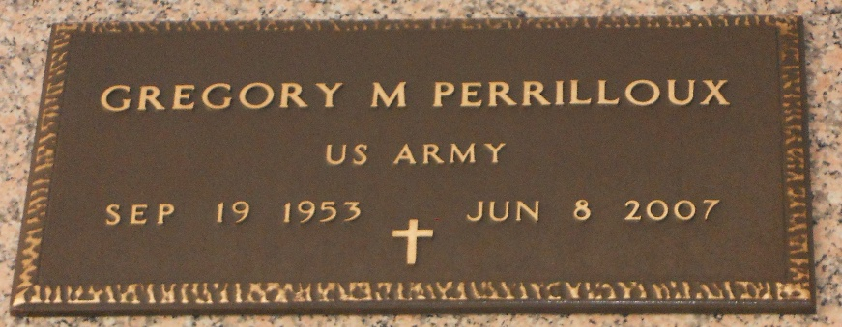

Photo by Team T-Lo

Gregory Michael Perrilloux, age 53, departed this life on Friday, June 8, 2007 in Destrehan, La.

Son of the late Frank, Sr. and Dorothy Perrilloux. Father of Dawn P. Warren. Brother of Frank Jr., Dwight and Reginald Perrilloux, Linda P. Tassin and Sandra P. Dickerson. Father-in-law of Aaron Warren. Also survived by 3 grandchildren; former wife, Pamela Perrilloux Pollard; brothers- and sisters-in-law; and a host of nieces, nephew, cousins and friends. A native of Reserve, La. and a resident of LaPlace, La.

Pastor, officers and members of Milesville Memorial C.O.G.I.C., Riverland Christian Center and all neighboring churches, employees of Keller William Realty are invited to attend the Funeral Service on Saturday, June 16, 2007 at 10:00a.m. at the above name Church, 123 Redemption Way, Reserve, La. Rev. Steve Perrilloux, Hosting Pastor, Bishop Ronald Frank, Officiating. Interment in St. Peter Cemetery, Reserve, La. Visitation on Saturday at the Church from 8:00a.m. - 10:00a.m. (ONLY). Service entrusted to HOBSON BROWN FUNERAL HOME Garyville, La. Informaton: (985) 535-2516

The Times-Picayune, New Orleans, Louisiana

June 15, 2007