Marcelle Eric Perrilloux Sr.

October 31, 1961 – December 16, 2009

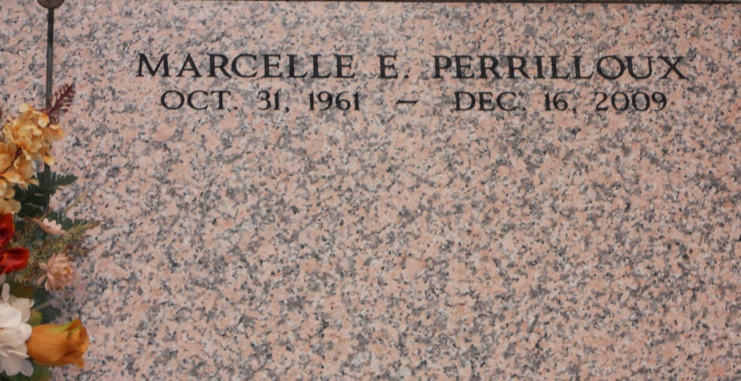

Photo by Team T-Lo

Marcelle Eric Perrilloux Sr., Owner and Operator of Perrilloux Trucking Service, departed this life on Wednesday, December 16, 2009, at Our Lady of the Lake in Baton Rouge, LA.

Beloved and Devoted Son of Geraldine S. Perrilloux and the late Wilfred (T-Boy) Perrilloux. Devoted Husband of Paula Preston Perrilloux. Father and Best Friend of Marcelle Eric Perrilloux, Jr., and a dear and devoted Doggie Daughter Ms. Anne Mae Perrilloux. Brother of Wanda P.(Charles) Calias, Judy P. (Jimmy) Green, Curtis Sr., (Anita), Elmo (Lee), and Keith (Minerva) Perrilloux, and the late Dwna Perrilloux. Son-in-Law of Nolan and Gussie Preston. Also survived by a host of nieces, nephews, 2 godchildren Nyla Elise Perrilloux and Celae Mazique other relatives and friends. A native and resident of Reserve, LA.

Services will be on Monday, December 21, 2009 at 11:00 am at Our Lady of Grace Catholic Church, Hwy. 44, Reserve, La. Father Joseph Rodney, officiating. Internment in St. Peter Cemetery, Reserve, La. Viewing at the church from 8:00 until service time. Service Entrusted to Hobson Brown Funeral Home Garyville, La., (985) 535-2516

The Times-Picayune, New Orleans, Louisiana

December 20, 2009