Margaret (Clement) Perrilloux

September 28, 1928 – August 25, 2004

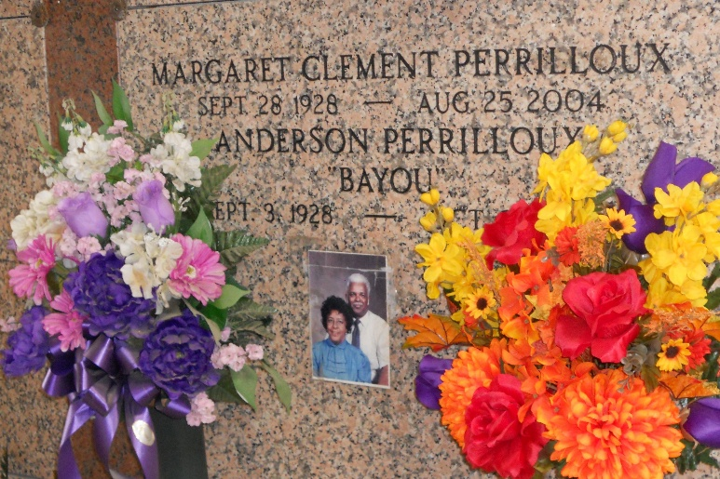

Photo by Team T-Lo

Margaret Clement Perrilloux On Wednesday, August 25, 2004 At Her Home In Reserve, La.

Daughter Of The Late Rosa Millet And Joseph Clement, Sr. Beloved Husband Of Anderson Perrilloux, Sr. Mother Of Lois Frank Of Reserve, Anderson, Jr. Of Chicago, Burnell Sr. Of Reserve And Wayne Of Baton Rouge. Sister Of Alvin, Willie And Donald Ray Clement, Joyce Houston, Lois Clark And Rose Mary Pidgeon, The Late Harriet C. Banks, Doris C. Jones, Joseph Clement Jr. And Ruth Clement. Preceded In Death By 1 Son-In-Law, Welman Frank And 1 Grandson, Courtney P. Perrilloux. Also Survived By 1 Aunt, Janet Sterling; 18 Grandchildren, 24 Great Grandchildren; 8 Sisters-In-Law, 5 Brothers-In-Law; 2 Daughters-In-Law And A Host Of Nieces, Nephews, Other Relatives And Friends. Age 75 Years. A Native And Resident Of Reserve, La.

Relatives And Friends Of The Family, Also Priest And Parishioners Of Our Lady Of Grace Catholic Church And All Neighboring Churches; Employees Of St. John Parish School Board, Shaw Construction, The Printing Source And Former Employees Of Godchaux-Henderson Sugar Refinery Are Invited To Attend The Mass Of Christian Burial At Our Lady Of Grace Catholic Church, 772 Highway 44, Reserve, La On Monday, August 30, 2004 At 11:00 A.M. Father Joseph Rodney, Ssj, Celebrant. Interment St. Peter Cemetery, Reserve, La. Visitation At The Above Named Church From 9:00 A.M. Until Mass Time. Recitation of The Holy Rosary At 10:15 A.M. Service By Robottom

The Times-Picayune, New Orleans, Louisiana

August 29, 2004