Melvin Joseph Perrilloux Sr.

August 3, 1949 – March 1, 2021

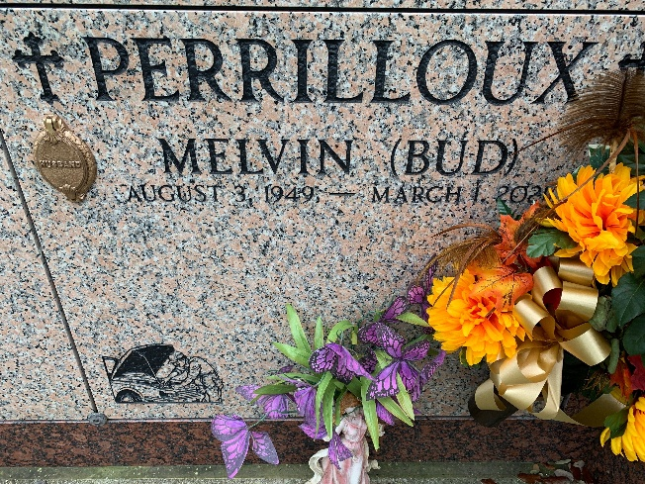

Photo by Team T-Lo

On August 3, 1949, Melvin J. "Bud" Perrilloux, Sr. was the third of ten children born to his parents, the late Joseph Luma and Ella Mae Perrilloux. He passed away peacefully on Monday, March 1, 2021 at the age of 71.

Melvin was first married to Cheryl Banks, and from that union three children were born, the late Gaynell Perrilloux-Ellis (Lamar), Melvin "BJ" Perrilloux, Jr. (Brandie) and Dayna Perrilloux-Mitchell (Blaine). Melvin was also the father of Samantha Thomas (the late Craig), and the late Steven Brown. One thing we all knew for sure about Bud was that he loved his children, his sixteen grandchildren and his eight great-grandchildren. His loving wife of twenty-one years Miranda Tregre-Perrilloux, who stayed by his bed side every day in the hospital from December to March until he took his last breath. Together they reared and raised his grandson Darien "Chuck" Young, who will miss his PawPaw dearly. His siblings were his one and only brother, Jerome Perrilloux (Lynelle) and sisters, Bessie Perrilloux Anderson (Randolph), Sylvia Perrilloux McLaurin (Melvin), Paulette Perrilloux Jones (Terry), Wanda Perrilloux Giles, Gwendolyn Perrilloux Mills (Alex), the late Vanessa Perrilloux, along with two stillborn children. Melvin was also surrounded by a host of nieces, nephews, other relatives and friends. His Godchildren were Terriyaka Alexander, Aprail Kirklin, and Keir Batiste. Bud was the Son-in-Love of Emelda Tregre and the late Wilbert Tregre and the brother-in-Love of Wilbert Tregre (Irela), Lisa Tregre-Wilder (Sherrod), Michael Tregre (Tanyia) and the late Wendell Tregre.

Melvin was raised in the Catholic faith and attended Our Lady of Grace Catholic Church until he and Miranda moved away, and he began faithfully attending Holy Ghost Catholic Church in Hammond, LA. He was a lover of baseball, and also played in his teenage years. He was educated in the St. John the Baptist Parish School System. Bud was a renowned Mechanic and operated his business with a spirit of excellence. Following in his daddy's footsteps, he mastered the craft with his heart, mind, body, and soul.

Bud had a special bond with his brother Jerome. Those two were inseparable, both became mechanics under their daddy's leadership. Joe followed the bible when it said, "Train up a Child". He trained his boys to work and showed them how to make a living for themselves and their families. He could have given them the fish, but instead he taught them how to fish for when he would no longer be there. But their mom was the one who fried the fish. She made sure her boys were fed in that shop. His father figure (his other daddy), the late Pepper Millet, was at FeFe's to pick up food for 12:00 every day. Mr. Pepper loved Bud and Jerome like his own sons, except when Bud would cap on his Saints. There were a few others that Bud took as his children, the late Bundy Stemley, Melvin Batiste, and Eric Smith. He also had special friends who stuck by him, but his go to was John August (Jel). When that wrecker moved, Jel was right there with him.

Lastly, if you really knew Bud, you knew he loved cooking and making soup for everyone who was sick. You couldn't tell him he didn't make the best gumbo. His love for his 1967 Chevelle, was indescribable. He loved cutting his yard and keeping it well-manicured. Once all of that was done, he would relax on his patio, after a soothing hot shower and a cool drink, watching the work he did in his yard as if it were a masterpiece. We all knew Bud to be a loving and caring person. Even with his sisters, he wasn't just their brother, but he acted like their dad. Especially Gwen being the baby, he really looked after her.

So, Melvin "Bud", God has called you home and your crown awaits you. All of those who have gone before you, you will see them. Your baby Gaynell will be so happy to see her dad and say, "See dad, I told you that you will see me again. I know Pookie, BJ, and Samantha are jealous because Steven and I have you now." RaShawn, Yana, and Lil Randy will jump for joy to see their Uncle Bud again. But no one will be happier to see him than his parents Joe and FeFe. They'll say our baby boy has come to be with us. What a Family Reunion!"

There will be a public walk-through visitation on Friday, March 12, 2021 from 5pm-7pm at Treasures of Life Funeral Services, 315 E Airline Hwy, Gramercy, LA 70052. On Saturday, March 13, 2021, a celebration of Bud's life will be held at New Wine Christian Fellowship, 1929 W Airline Hwy, Laplace, LA 70068. Visitation will be held from 9am-10:30am. Service will begin at 10:30am. Entombment to follow at St. Peter Catholic Church Cemetery in Reserve, LA. Final care entrusted to Treasures of Life Funeral Services. Due to CDC (covid-19) guidelines and restrictions, masks and social distancing are required!!

The Times-Picayune, New Orleans, Louisiana

Mar. 10 to Mar. 13, 2021  
Contributed by Jane Edson