Noland Joseph Perrilloux Sr.

March 30, 1925 – September 6, 1993

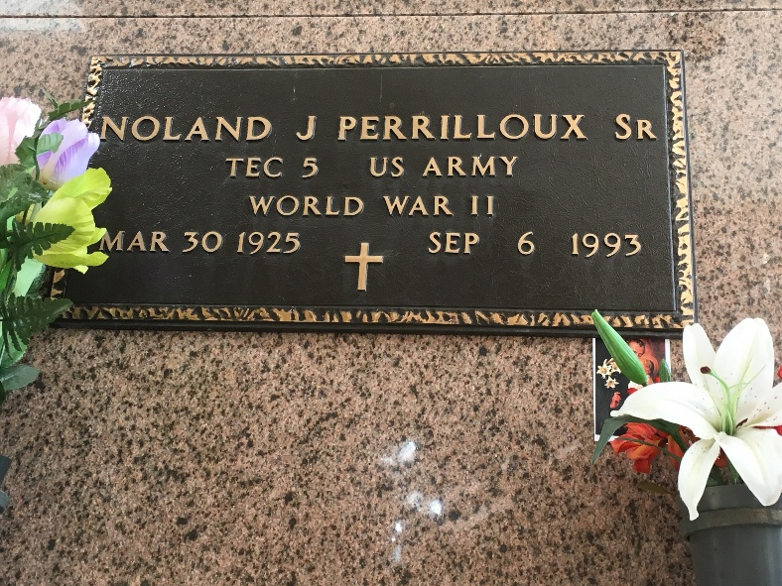

Photo by Team T-Lo

Noland Joseph Perrilloux Sr., A Self-Employed Brick Mason, Died Monday Of Cancer At His Home. He Was 68. Mr. Perrilloux Was A Lifelong Resident Of Reserve. He Was In The Army During World War II In Alaska. He Was A Subcontractor For Norco Construction Co. For Many Years And Was Instrumental In Building Many Churches, Banks, Schools And Homes In The River Parishes. He Was A Member Of Our Lady Of Grace Catholic Church, Where He Worked On Many Projects To Improve The Church And School. He Was On Many Church Committees And Organizations. In 1976, The Church Presented Him With The Pastor's Choice Award And Honored Him In 1993 For His Christian Life In The Church And Community.  
 Survivors Include His Wife, Audrey Gravois Perrilloux; A Daughter, Charmaine Perrilloux; Three Sons, Clinton Sr., Noland Jr. And Darryl Perrilloux Sr. Of Houston; A Sister, Earline Perrilloux; Three Brothers, Rodney, Remey And Louis Perrilloux Of Washington, D.C.; Nine Grandchildren; And Two Great-Grandchildren.

The Times-Picayune, New Orleans, Louisiana

September 10, 1993