Paul Anthony Perrilloux Sr.

September 7, 1937 – December 17, 2016

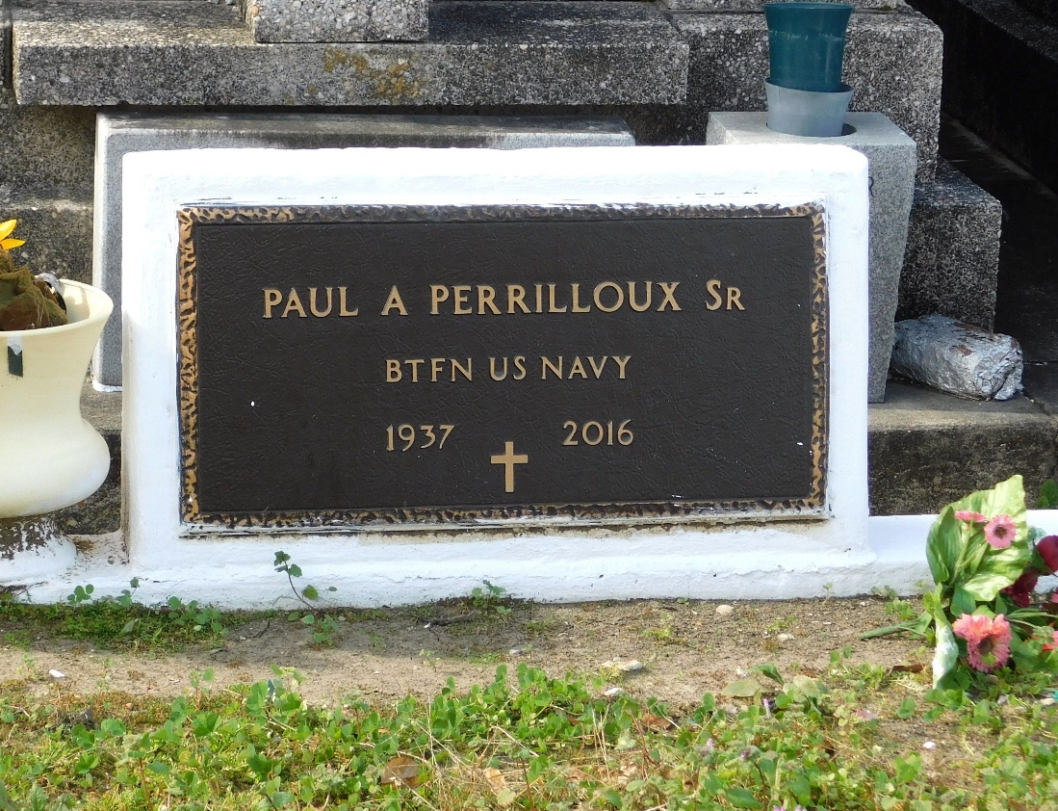

Photo by Team T-Lo

Paul Anthony Perrilloux, Sr. on Saturday, December 17, 2016 at his home in Reserve, LA.

Son of the late Mary Wilson and Rodney Joseph Perrilloux. Husband of Dorothy "Dot" Perrilloux. Father of Paul A. Perrilloux, Jr., Deborah Perrilloux-Cobbs, Derrick J. Perrilloux, Stacey R. Michael Perrilloux and Michael P. Perrilloux Stepfather of Arthur Williams, Jr.. Brother of Marvin J. Perrilloux, Sr. and the late Marcel Perrilloux. Also survived by 18 grandchildren, 21 great grandchildren and a host of nieces, nephews, cousins, other relatives and friends. Age 79 years. A native and resident of Reserve, LA.

Relative and friends of the family, also priest and parishioners of Our Lady of Grace Catholic Church and all neighboring churches are invited to attend the Funeral Mass at Our Lady of Grace Catholic Church, 772 Hwy 44 (River Road), Reserve, LA on Tuesday, December 27, 2016 at 10:00 AM. Father Christopher Amadi, Celebrant. Interment will be private. Visitation at the above named church from 8:00 AM until Mass time. SERVICED BY ROBOTTOM

The Times-Picayune, New Orleans, Louisiana

December 19-25, 2016