Reginald Perrilloux Jr.
December 21, 1979 – June 25, 2023

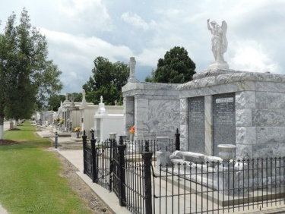

Reginald Perrilloux, Jr. was born on December 21, 1979 to the union of Reginald and Margie Perrilloux, in New Orleans, LA.
Reginald was christened at the age of one year old at Beech Grove Baptist Church by his godparents, Whitney Allan Dickerson and Delvekio Cambre. Reginald also accepted Christ as his Savior at the age of nine and was baptized at the same church. Reginald attended East St. John High School in Reserve, LA. He furthered his education at River Parishes Community College where he studied structural welding and pipe welding. Reginald also attended Coastal Trucking School, in Hammond, LA. He was employed at River Parish Disposal in Metairie, LA. Reginald was also employed as a roll off truck driver.
Reginald was very talented and had many hobbies. He was a skilled welder. He also loved cooking, eating eggs and he liked his coffee black. Reginald loved playing chest and was a great artist. He enjoyed reading scriptures from the Holy Bible and then writing them out. Reggie, as he was affectionately called, had a heart of a giant, even though he only stood 5 feet and 7 inches tall. He was full of jokes and an old soul.
Reginald Perrilloux, Jr. departed this life on June 25, 2023. He was preceded in death by grandparents Frank Perriloux, Sr., Dorothy Perrilloux and Mary Stewart; one uncle Gregory Perrilloux and one aunt Barbara Stewart Brown.
Reginald leaves to cherish his precious memories fiancé Chyzelle Brown; one son, Tyii Perrilloux; one daughter, Demi Perrilloux; father, Reginald (Sandra) Perrilloux; mother, Margie Stewart; one brother, Bryan Perrilloux; two sisters: Lynntrell (Timothy) Brown and Joy (Jarett) Shorts; aunts: Linda (August) Tassin, Sandra (Whitney Allan) Dickerson, Claudia Johnson, Mearl and Nicole Stewart, and Chericka (Kirby) Smith; uncles: Frank and Dwight (Barbara) Perrilloux, James, Jr. (Mary) Stanley, Sterling, David (Sharon) and Charles Stewart; niece, Amari Brown; nephew Ti Brown and a host of cousins and friends.
Celebration service on Saturday, July 8, 2023 at 10:00 at New Wine Christian Fellowship, 1929 W. Airline Hwy., Laplace, LA 70068, Rev. Neil Bernard officiating, Visitation will begin at 8 am Interment: St. Peter Cemetery Reserve, LA. Professional services entrusted to the caring staff of Hobson Brown Funeral Home, 134 Daisy St., Garyville, La. 70051, 985-535-2516.

The Times-Picayune, New Orleans, Louisiana
July 7-8, 2023

