Rodney Joseph Perrilloux

October 25, 1914 – April 5, 2008

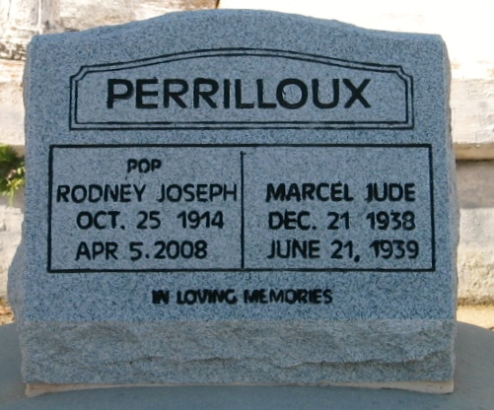

Photo by Bobby

Rodney Joseph Perrilloux on Saturday, April 5, 2008 at St. Elizabeth Hospital, Gonzales, LA.

Son of the late Marguerite and Remey Perrilloux. Husband of the late Mary Perrilloux. Father of Marvin (Augustine) Perrilloux, Sr., Paul (Dorothy) Perrilloux, Sr. and the late Marcel Perrilloux. Brother of Earline, Remey and Louis Perrilloux, the late Marguerite P. Leche, Beatrice Jones, Nolan Perrilloux, Sr., Deborah and Geneva Perrilloux. Grandfather of Ingrid Perrilloux, Marvin "Butch" Perrilloux, Jr., Warner Anderson, Sr., Bonnie Anderson, Paul "Pete" Perrilloux, Jr., Derrick "Spookie" Perrilloux, Stacy Perrilloux, Deborah Perrilloux Cobbs and Michael Paul Perrilloux. Also survived by 31 great grandchildren, 11 great great grandchildren and a host of nieces, nephews, other relatives and friends. Age 93 years. A native and resident of Reserve, LA.

Relatives and friends of the family, also priest and parishioners of Our Lady of Grace Catholic Church and all neighboring churches are invited to attend the Mass of Christian Burial at Our Lady of Grace Catholic Church, 772 Highway 44 (River Road), Reserve, LA, on Saturday, April 12, 2008 at 11:00 AM. Father Joseph Rodney, Celebrant. Interment St Peter Cemetery, Reserve, LA. Visitation at the above named church from 9:00 AM until Mass time. SERVICED BY ROBOTTOM

The Times-Picayune, New Orleans, Louisiana

April 11-12, 2008