Yana Niquel Perrilloux
July 19, 1977 – January 8, 2001

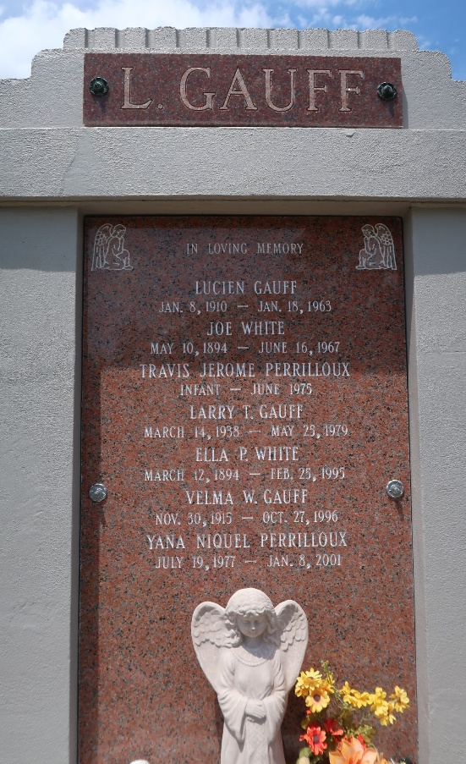

RESERVE - Yana Niquel Perrilloux, 23, a native and resident of Garyville, died Jan. 8.
She was the daughter of Jerome and Lanelle Gauff Perrilloux and sister of Gabrielle Perrilloux. She was also the granddaughter of Joseph and Ella Perrilloux and the late Lucien Sr. and Velma Gauff and great-granddaughter of the late Joe and Ella White and Ernest and Azalea Perrilloux.
She was a graduate of Our Lady of Grace School, a 1995 graduate of St. Charles Catholic High School and a psychology senior at the University of New Orleans, where she was in the Alpha Kappa Alpha sorority, and was employed at the New Orleans Airport Hilton.
Services are today at 11 a.m. at Our Lady of Grace Catholic Church, Reserve, with interment at St. Peter Cemetery, Reserve. Visitation starts at 9 a.m.
L'Observateur, LaPlace, Louisiana
January 13, 2001

