Jordan Francis Perry Sr.

June 26, 1935 – April 6, 2015

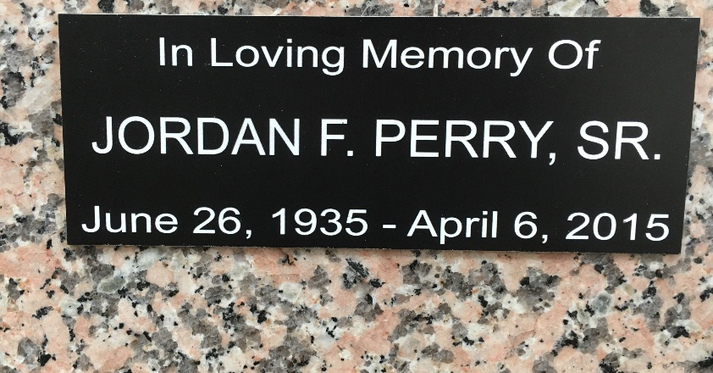

Photo by Team T-Lo

Jordan Francis Perry Sr. passed away peacefully on Monday, April 6, 2015, surrounded by family.

Perry was the only child of John Perry and Olga Kowalsky Perry of Passaic, N.J. He was preceded in death by his wife of 25 years Musette Mewbourne Perry of Columbus, Ga., and the late Madelyn Millet Perry of LaPlace.

Perry is survived by his children Jordan Perry Jr., Wesley Perry (Michelle), Wayne Perry (Norma), Cindy Hammond (Mark), Andrea Whetzel Fredrick and Tina Cotton of Columbus. He is also has 15 grandchildren and 12 great grandchildren.

He served as a helicopter mechanic in the U.S. Army. He was employed by Shell Norco for 30 years. Perry loved to travel and was a dedicated leader of the Boy Scouts of America. His was kind and his generous spirit will live on in all of us. He will be missed more than words can express. A private service will be held at a later date.

L'Observateur, LaPlace, Louisiana

April 9, 2015