Micheline (Petrona) Petrolia
January 1, 1862 – July 3, 1933

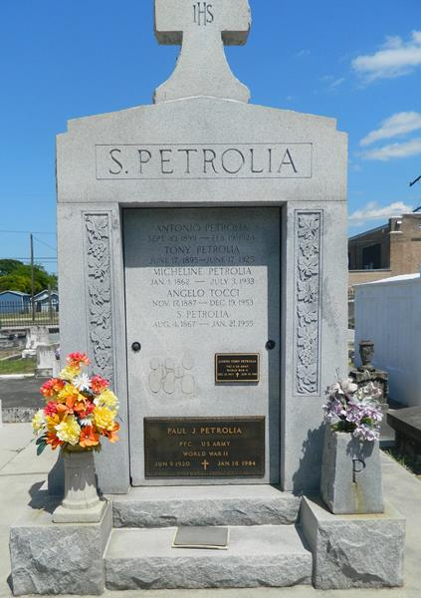

PETROLIA---In LaPlace, La. on Monday, July 3. 1933, at 9:30 o'clock a.m., MADELEINE (sic – Micheline) PETRONE, beloved wife of Salvadore Petrolia: mother of Angelo Tocci, Joseph and Emile Petrolia, Mrs. Joseph Barraco, and the late Thomas and Anthony Petrolia; aged 70 years, a native of Cosenza, Italy, and a resident of La Place, La. for the last 29 years.
New Orleans (LA) Item
Tuesday, July 4, 1933 - page 2

