Emile A. Picou
April 21, 1883 – May 31, 1934

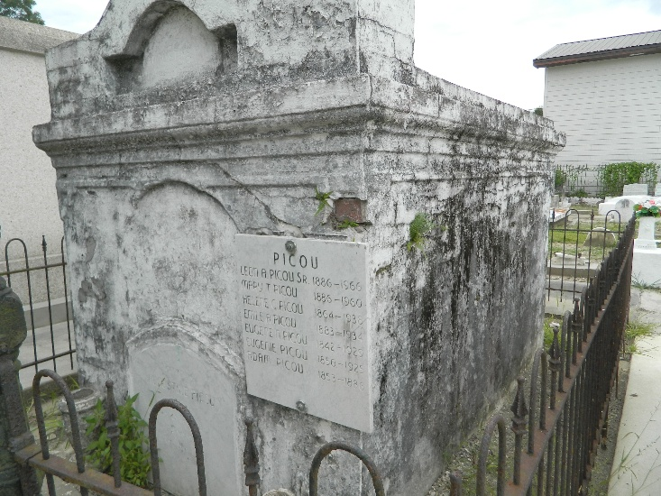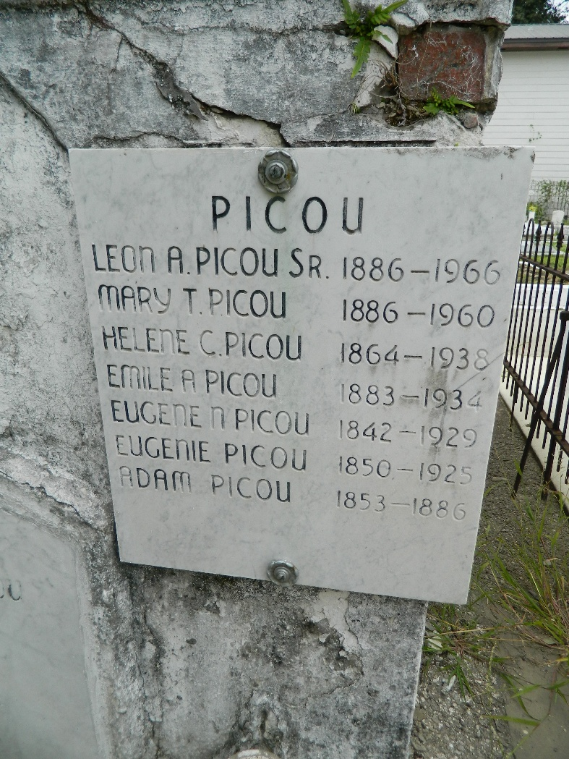

Emile A Picou was a native of St John the Baptist Parish, Louisiana. He served as a Justice of the Peace in the 6th Ward of the parish. He was elected Sheriff of St John the Baptist Parish in 1920, defeating William B Hart, son of the late sheriff. He also was the manager of the Garyville baseball team. Mr Picou died at his residence on Thursday 31 May 1934. Funeral services were 1 Jun 1934 at St Peter Church, Reserve, Louisiana, with interment in St Peter Cemetery.
He attended the Chenet Institute in New Orleans, completing the commercial course at the Institute. He engaged in business in Garyville for several years in partnership with his brother Leon Picou.

Unknown source

