Leon Adam Picou Sr.
August 10, 1886 – January 24, 1966

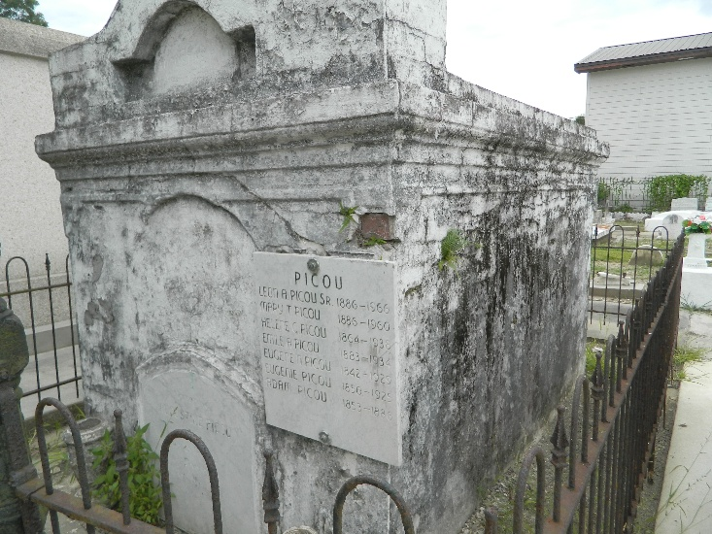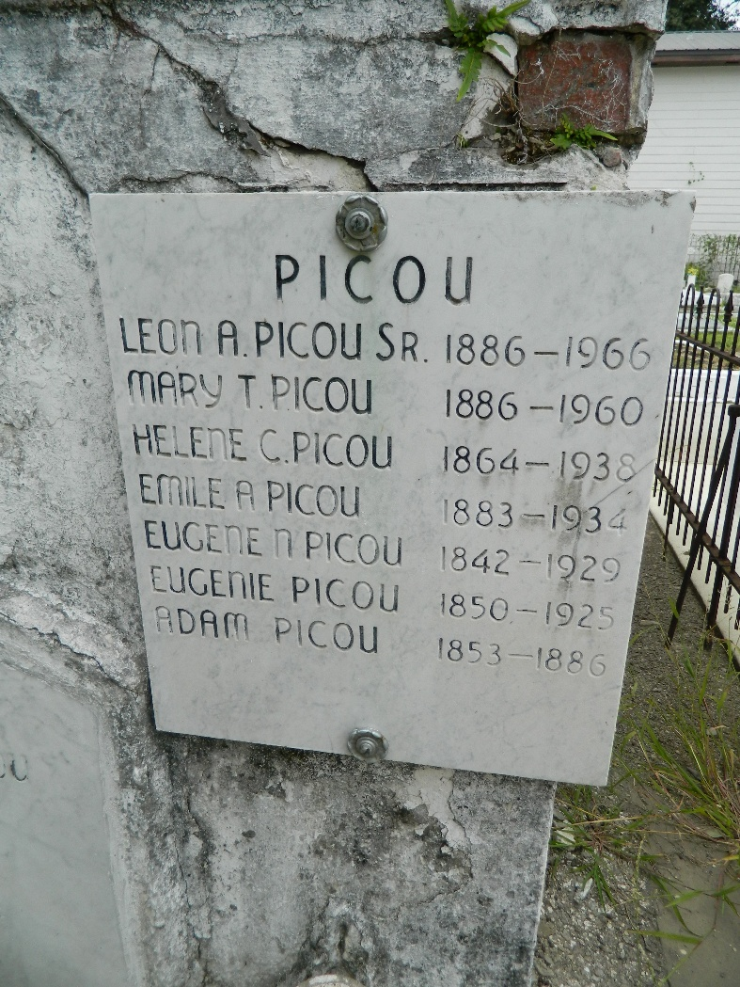

Age 79 years, a native and resident of Garyville, Louisiana.

Husband of the late Mary Tufant, father of Mrs. B C Vega of Napoleonville, Louisiana, Leon A Picou Jr of St Francisville, Louisiana, and Mrs. Hickman Carry of Baton Rouge.

He was the son of the late Adam Picou and Helen Chauff.

Services were Tuesday 25 Jan 1966 at St Hubert Church, Garyville, with interment in St Peter Cemetery, Reserve, Louisiana.
The Times-Picayune, New Orleans, Louisiana
25 Jan 1966

