Detroit Pidgeon Sr.
December 29, 1927 – February 14, 2023

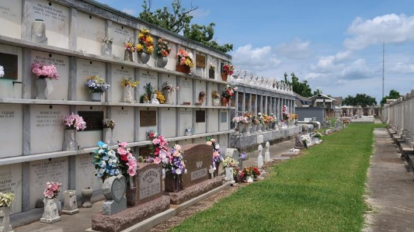

Detroit (BeBe) Pidgeon, Sr., age 95, was called to his eternal home on Tuesday, February 14th at 6:51 A.M.
Detroit was born on December 28, 1927 in St. Gabriel, LA to the late Anderson Pidgeon and Telvina Felton Pidgeon. He was the second of three sons: Robert the oldest and Wilman the youngest. On October 26, 1946, he married Edith Leona Keller. Nine children were born from that union: Detroit Jr., Dolores, Gloria, Brenda, Michael, Donald, Ronald, Reginald, and Deborah.
Detroit was a lifelong parishioner of Our Lady of Grace Church. He was a devoted Usher. Before his passing, he was honored as one of several oldest living members of Our Lady of Grace.
He retired from Colonial Sugar Refinery in 1987 after over 30 years of service where he worked as a mechanic. He also had a side job repairing automobiles; a skill that was self-taught. Before his passing, you could find him relaxing in L.J. and Dolores's sunroom, watching his favorite TV shows, spending time with family, or snoozing.
He leaves to cherish his memories his devoted children, Detroit Jr. (Veronica) Pidgeon, Dolores (L.J.) McCoy, Brenda P. Duhe, Ronald (Charlotte) Pidgeon, and Deborah (Raymond) Nelson. He was a devoted grandfather to 16 grandchildren, 24 great-grandchildren and 13 great-great-grandchildren.
He is also survived by his loving and devoted brother, Wilman (Dianne) Pidgeon; nieces, Mary Ann Branch and Barbara Bynum; nephews, Roger Johnson and Roy Pidgeon; in-laws, Ronnie Keller (Lorenza Roberts), Hattie Creecy, Patricia Pidgeon, Rev. Eric Keller and Joseph Bobo, and a host of other relatives and friends.
Detroit was preceded in death by his wife of 66 years, Edith Keller Pidgeon; parents, Anderson and Telvina Pidgeon; four children, Michael, Reginald, Donald Pidgeon, and Gloria P. Desselle; brother, Robert Pidgeon, Sr.; father and mother-in-law, Anatole and Leona Keller; sisters-in-law, Lillie Pidgeon, Dorothy Keller, Myrtle Valentine, Mildred Taylor, Olivia Keller, Evola Keller, and Althea Keller; brothers-in-law, Ferdinand Valentine, Raymond, Roy, Robert Keller, and Ernest Taylor, Jr.; sons-in-law, Jerome Taylor, Lee Duhe, Gregory Clark, Sr., and Percy Desselle; aunt, Mary Ellis; uncle, James Artberry; cousin, Isaac Redditt Sr.; nieces, Rosemary Hardy and Joyce Johnson; nephews, Robert Jr., Kevin and Nathaniel Pidgeon; longtime friend, Percy Zeno Sr., and family friend Vernon Ellis.
He will be missed by his grandchildren, a host of nieces, nephews, other relatives, and friends. A Mass of Christian Burial will be held Thursday, February 23, 2023, at Our Lady of Grace Catholic Church, 772 LA-44 Reserve, LA 70084. Fr. Goodwin Ani, SSJ, celebrant. Visitation will be from 8:00 am until 10:00 am. Mass will begin at 10:00 am. Entombment will follow at St. Peter Catholic Church Cemetery, Reserve, LA 70084.

Treasures of Life Funeral Services, Gramercy, Louisiana

