Susan R. (Laurent) Pierce
October 12, 1962 – June 6, 2018

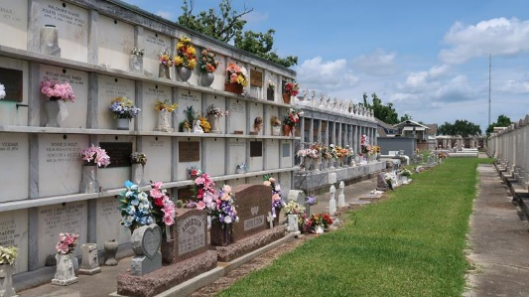

Susan Laurent Pierce passed away on Wednesday, June 6, 2018, in Covington at the age of 55. Susie was born in New Orleans, graduated from Riverside Academy in Reserve, and lived in Baton Rouge for the majority of her life – most recently residing in Covington.
Susie had a passion for art from a young age, which led to her earning multiple awards and being recognized at the finals of the World Body Painting Festival in Austria. She shared her creativity through teaching art, starting her own event entertainment business, and co-founding the "LA Fete" body and face painting convention of New Orleans. She also had a love of nature, reading, and writing.
Daughter of the late Kenneth and Lautice Laurent. Mother of Samantha Pierce and Jacqueline Pierce. Spouse of Chris Pierce for 31 years. Sister of David Laurent, Anna "Peanut" Laurent Taylor, Paul Laurent, and the late Stephen Laurent. Survived by her nephew and nieces. Her loving feline companion of 17 years, "Stellie," will miss her.
Relatives and friends of the family are invited to attend a Mass of Christian Burial at St. Peter Catholic Church, 1550 Hwy. 44, Reserve, on Saturday, June 9, 2018. Visitation begins at 10:30 a.m. with Mass at 11:30 a.m. Interment immediately following at St. Peter Cemetery, Reserve, LA. Serenity Funeral Home, Covington, in charge of arrangements (985) 875-1131.

The New Orleans (LA) Advocate
Jun. 7 to Jun. 9, 2018

