Anita L. (Keys) Pierre
September 25, 1959 – April 20, 2015

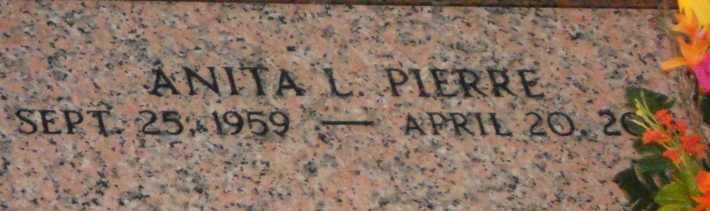
Photo by Team T-Lo

Anita Keyes-Pierre, age 55, departed this life on Monday, April 20, 2015.
She leaves to cherish her memory her step-father, Albert French, Jr.; Children: Grant, Mark, Donavon, Ashton and Jeremy Pierre; Sisters: Suzanne Pruitt, Evelyn French, Alanna Ross, Aisha Bass, and Sterling W. Keys Jr.; other relatives and friends.
Funeral service on Saturday, April 25, 2015 at Destiny Christian Center, 612 Main St, Laplace, LA 70068 at 10:00 am, viewing at 9:00 am. Rev. Steve Allen Pastor. Internment St. Peter Cemetery, Reserve, La. Service Entrusted to Hobson Brown Funeral Home Garyville, La 70051 985-535-2516

The Times-Picayune, New Orleans, Louisiana
Apr. 23 to Apr. 24, 2015

