Paul Russell Placide Jr.

October 31, 1959 – November 19, 2005

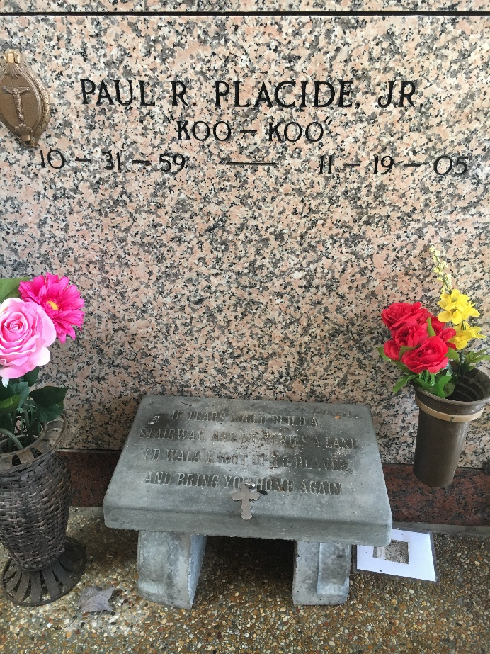

Photo by Team T-Lo

Paul (Koo-Koo) Russell Placide, Jr. Of Reserve, La. On Saturday, November 19, 2005 At River Parishes Hospital, Laplace, La. Owner Of Paul's Auto.

Beloved Son Of Paul Placide, Sr. And Gladys Anderson Placide. Father Of Roderick, Kaylon, Paul Placide III, Alicia Jackson, Cast Lee And Ilesha Verner. Grandfather Of Jazmyne And Jadiah Placide. Brother Of Maxine (Edward) Robinson, Lellie Ann (Craig) Sterwart Of Laplace, La And Todd Anthony Placide Of Reserve, La. Grandson Of The Late Budwin, Marie Placide, John And Elizabeth Kennard Telfair Anderson. Also Survived By A Host Of Nieces, Nephews, Aunts, Uncles, Cousins & Friends. A Native Of Garyville, La. And A Resident Of Reserve, La. Age 46 years.

Relatives And Friends Of The Family, Also Priest And Parishioners Of Our Lady Of Grace Catholic Church, New Pilgrim B.C., First Community Antioch And Neighboring Churches, Are Invited To Attend A Mass Of Christian Burial On Saturday, November 26, 2005 At 11:00 A.M. From Our Lady Of Grace Catholic Church, 772 Hwy. 44, Reserve, La. Father Joseph Rodney, Celebrant. Recitation Of The Rosary 10:00 A.M. Interment St. Peter Catholic Church Cemetery, Reserve, La. Visitation On Friday, November 25, 2005 5-8 Pm From The Baloney Funeral Home, 399 Earl Baloney Dr., Garyville, La. After 9:00 Am On Saturday At The Church. The Baloney Funeral Home, LLC, 399 Earl Baloney Dr., Garyville, La. 70051 (985) 535-2540.

Times-Picayune, New Orleans, Louisiana

November 25, 2005