Paul Russell Placide Sr.
September 28, 1935 – March 2, 2020

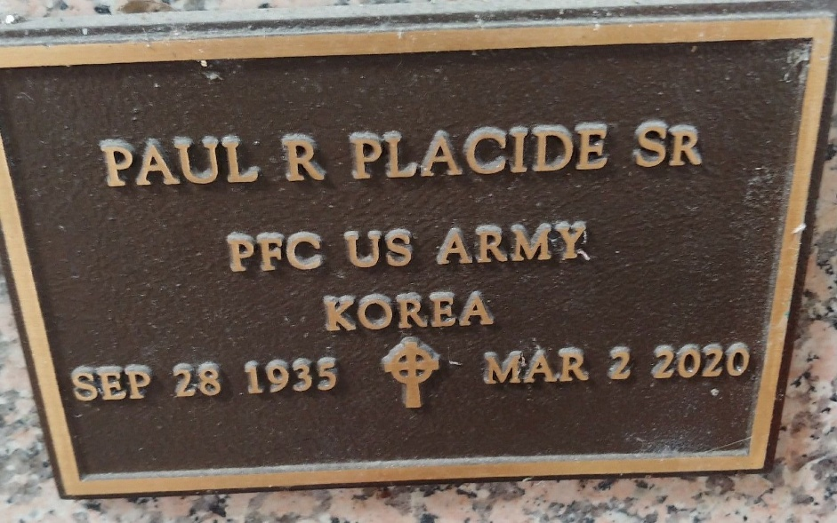
Photo by Team T-Lo

“We are confident, I say, and would prefer to be away from the body and at home with the Lord.” 2 Corinthians 5:8
Paul Russel “Poon Toon” Placide, Sr. peacefully departed this life on Monday, March 2, 2020 in LaPlace, LA at the age of 84. One of seven siblings, he was born on September 28, 1935 to Budwin and Marie Mercier Placide in (Silvertown) Reserve, LA.
For many years, Paul faithfully attended Our Lady of Grace Catholic Church in Reserve, LA, until his health physically hindered his ability to be present on Sundays. Paul had also been previously baptized and educated at Our Lady of Grace Catholic Church and school, graduating in 1953. Immediately following high school graduation, on June 25, 1953, at the age of 17, he was inducted into the United States Army where he fought and served in the Korean War. PFC (E-3) Paul Placide received an Honorable Discharge on May 14, 1955, and later served in the United States Army Reserve where he was Honorably Discharged on June 22, 1964.
Following his service to the country, Paul was a truck driver for 50 years, beginning at Trosclair Trucking. Paul worked and retired from Tull Metal Trucking Company in 1988 where he received an award for ten years of service as well as membership into the Million Mile Club for serving without any accidents. In his early years, he loved fishing, cooking various dishes, reading his newspaper, sipping on his coffee, and going to the casino, or as he would often say “ca’sino”. He also enjoyed taking his daily walks to the post office and local grocery store, Greggs. From his marriage to his former wife, Gladys Placide, four children were born.
Paul leaves to cherish his memories his children Maxine Marie (Edward) Robinson, Todd Anthony Placide, and Kellie Ann (Craig) Stewart, twenty-one grandchildren, thirty great-grandchildren, and one great-great-grandson, Ace Brown, as well as other nieces, nephews, godchildren, relatives and friends. Paul was preceded in death by his son, Paul Russell “KooKoo” Placide, Jr., parents Budwin and Marie Mercier Placide, brothers Budwin Jr., Wilson, James, and Edward Placide, sisters Carol Placide Lennix and Dianna Placide Alexander, and devoted friend Larry Cook, Sr.
A Mass of Christian Burial will be held at Our Lady of Grace Catholic Church 772 Hwy 44, Reserve, LA on Friday, March 13, 2020 at 10:00 a.m., Father Christopher Amadi, Celebrant. Visitation will begin at 8:15 a.m. Entombment at St. Peter’s Catholic Church Cemetery. Final care has been entrusted to Treasures of Life Funeral Services, 315 E. Airline Hwy Gramercy, LA 70052.

Treasures of Life Funeral Home, Gramercy, Louisiana
March 9, 2020

