Albert Joseph Poche Sr.

July 12, 1884 – June 15, 1959

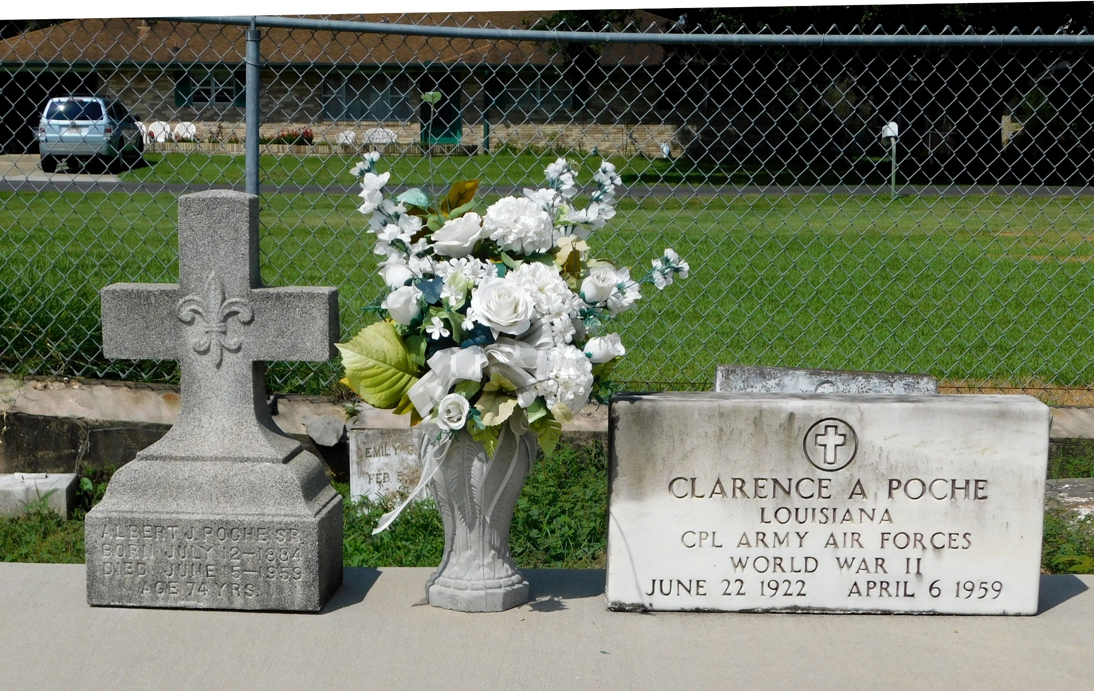

Photo by Mary Agnes hammett

Albert Joseph Poche Sr died Monday, 15 Jun 1959 at 10:20 am.

He was the husband of the late Emilie Battard and the father of Albert Jr, Jules, and Mrs. Alfred Miller Jr, all of Reserve, Louisiana, Amy Raffray of Westwego, Louisiana, Mrs. Ewell Kilburn of New Orleans, Mrs. Andrew Surmik of Destrehan, Louisiana, Mrs. Herman Deslatte of Norco, Louisiana, Mrs. Joe LeBouef of Lutcher, Louisiana, Raymond Poche of Baltimore, Maryland, and the late Clarence Poche.

Services were Wednesday, 17 Jun 1959 at St Peter Church, Reserve, with interment in St Peter Cemetery, Reserve.

Times-Picayune, New Orleans, Louisiana

June 17, 1959