Barbara Ann (Jouty) Poche

October 6, 1939 – November 14, 2005

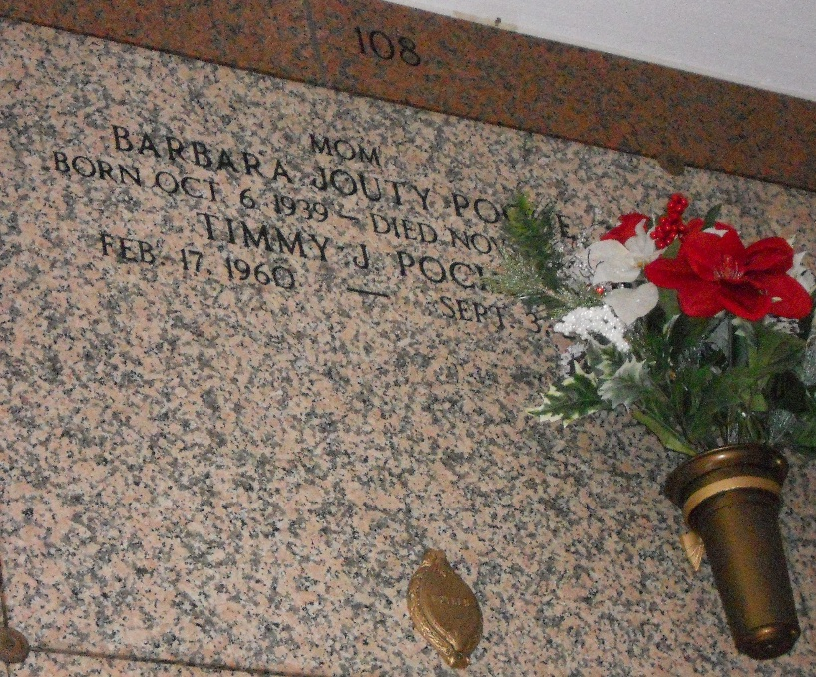

Photo by Mary Agnes hammett

Barbara Jouty Poche on Monday, November 14, 2005 at 5:00 am. Beloved wife of late A.J. Poche. Mother of Rodney, Timmy, and Randy Poche and Trudy Caronna. Grandmother Dakota Poche and the late Amanda Poche.

Daughter of the late Frank and Rita Jouty. Sister of the late Frank Jouty, Jr. Age 66, a native and resident and of Laplace.

Relatives and friends of the family are invited to attend services. Visitation at Millet Guidry Funeral Home, 2806 W. Airline Hwy., Laplace, on Tuesday, November 15, 2005 from 5pm until 9pm. and on Wednesday from 8am until 10am. Followed by Religious Services at the funeral home chapel at 10:00 am. Burial St. Peter Cemetery, Reserve.

Times-Picayune, New Orleans, Louisiana

November 15, 2005