Emilie M. (Battard) Poche

August 6, 1889 – July 4, 1927

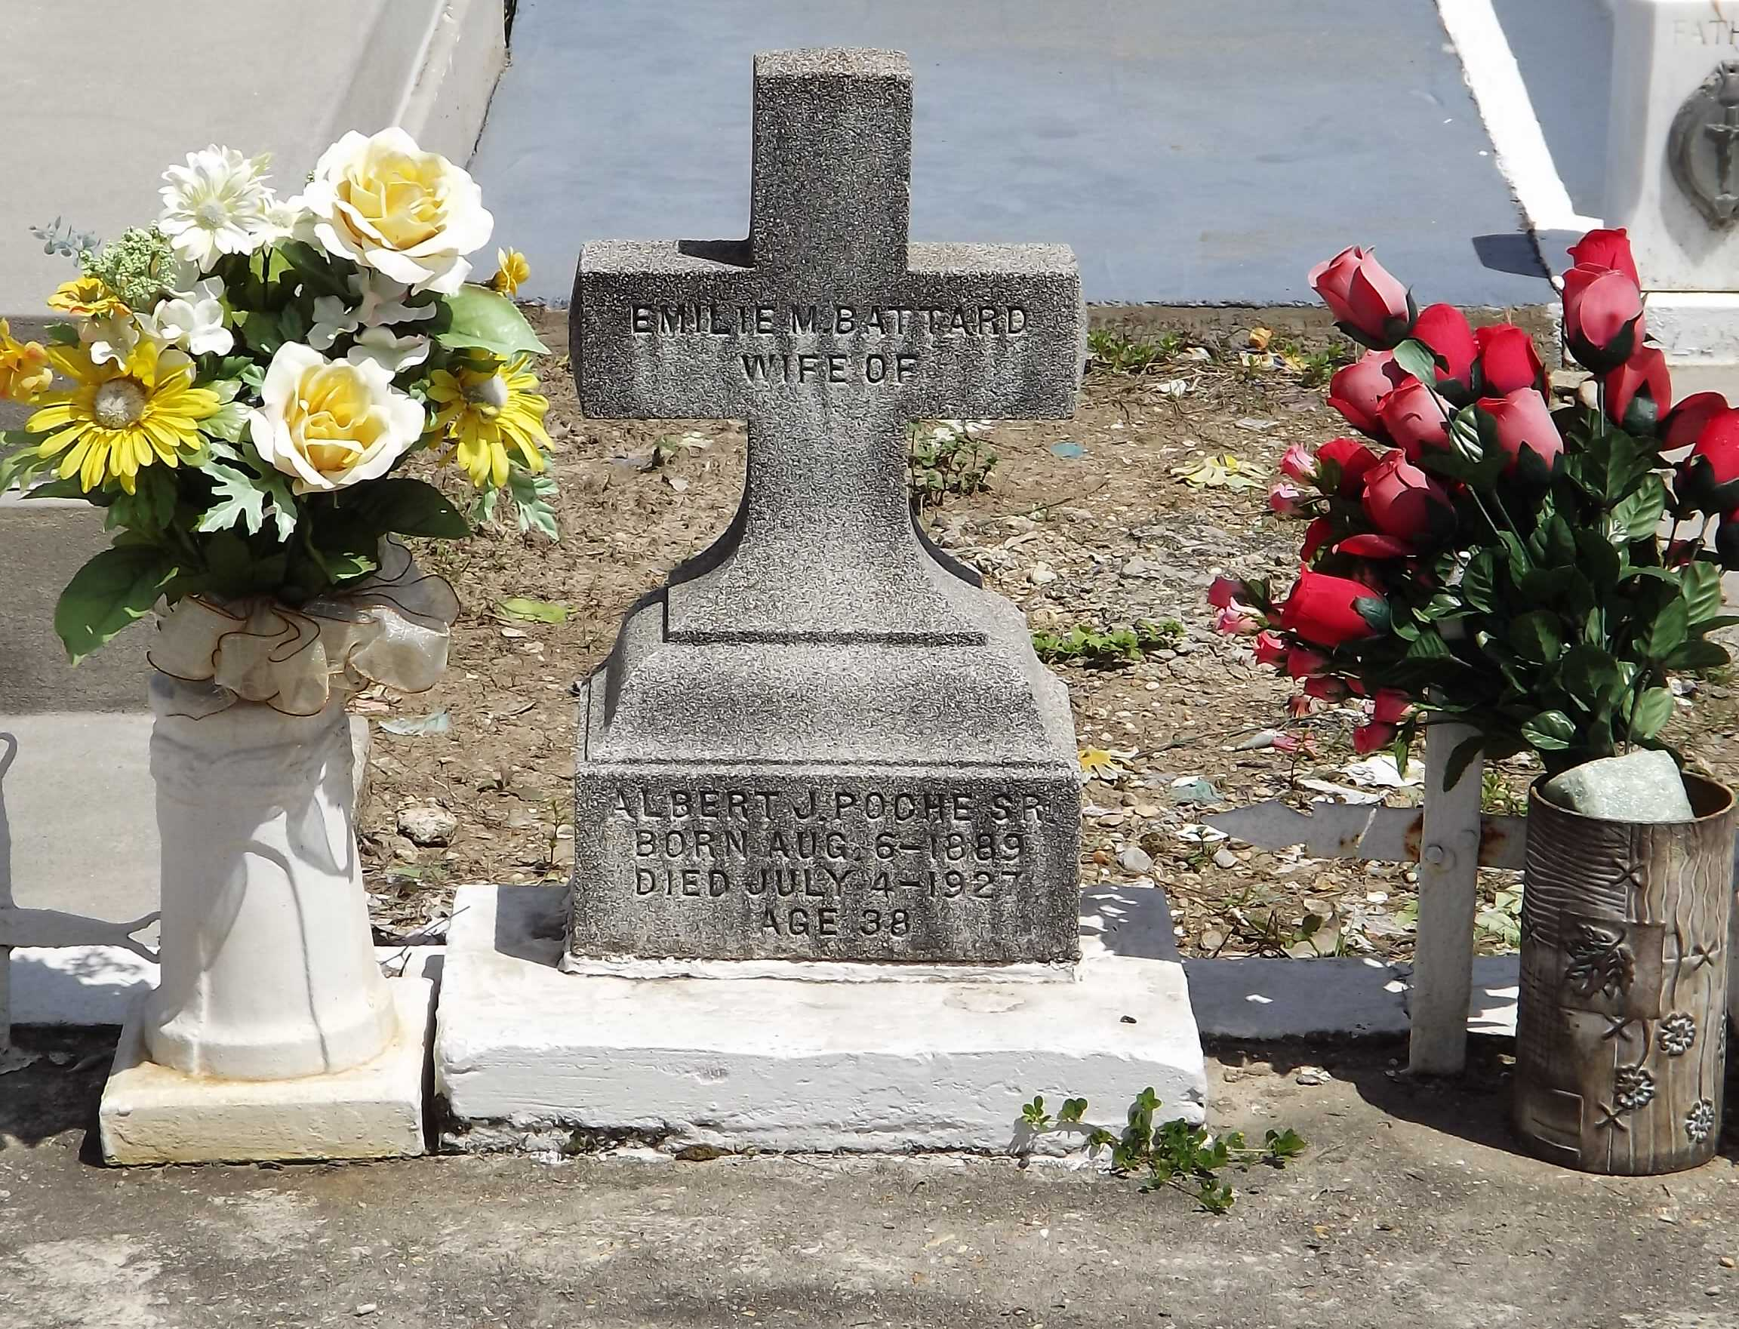

Photo by Mary Agnes hammett

Mrs. Albert Poche, née Emilie Battard, died Monday at age 38 years and 6 months at her home in Lions, Louisiana.

She is survived by ten children, four brothers and three sisters and her husband. Her mother died 5 days ago.

Interment was Tuesday in St Peter Cemetery, Reserve, Louisiana.

L'OBSERVATEUR, LaPlace, Louisiana

9 Jul 1927