Oleida (Remondet) Poche

November 14, 1915 – July 30, 2010

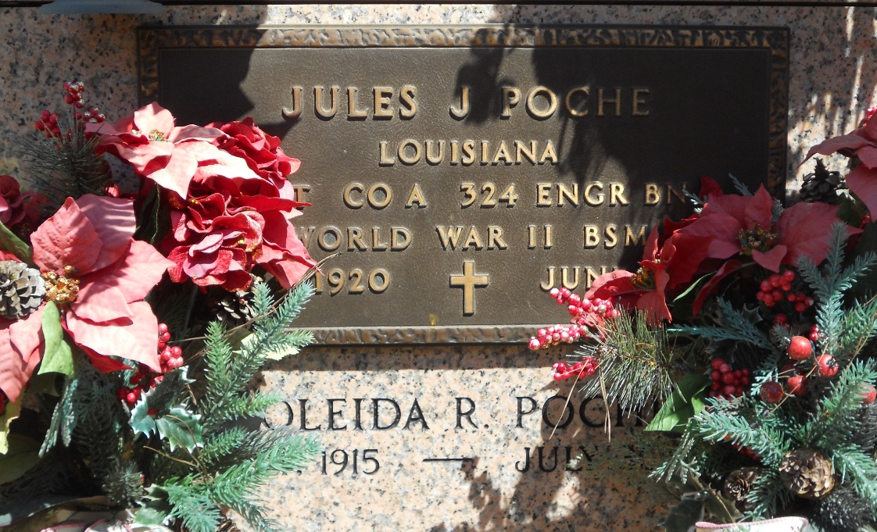

Photo by Team T-Lo

Oleida Remondet Poche on Friday, July 30, 2010.

Beloved wife of the late Jules Poche. Mother of Glenda (Donald-Red) Vicknair, Marla (Kevin) Berteau and Judy (Paul-T-Pop) Trosclair. Special grandmother of Mary Kay Vicknair, Julie (Henry III) Cox, Travis Trosclair, Benjamin Trosclair. Great grandmother of Henry IV. Also survived by two step granddaughters and their children Michelle B. Miller (Mihailey and Mallorey) and Ashley B. Andrade (Rylie).

Daughter of the late Denis Remondet and Ida Kleibert. Sister of Cleven Remondet, Beatrice Hymel, Eloi Remondet, Naomi Roussel and the late Lorina Poche, Aurelia Remondet and Eugenie Remondet.

Times Picayune, New Orleans, Louisiana

August 1, 2010