Timothy J. Poche

February 17, 1960 – September 3, 2015

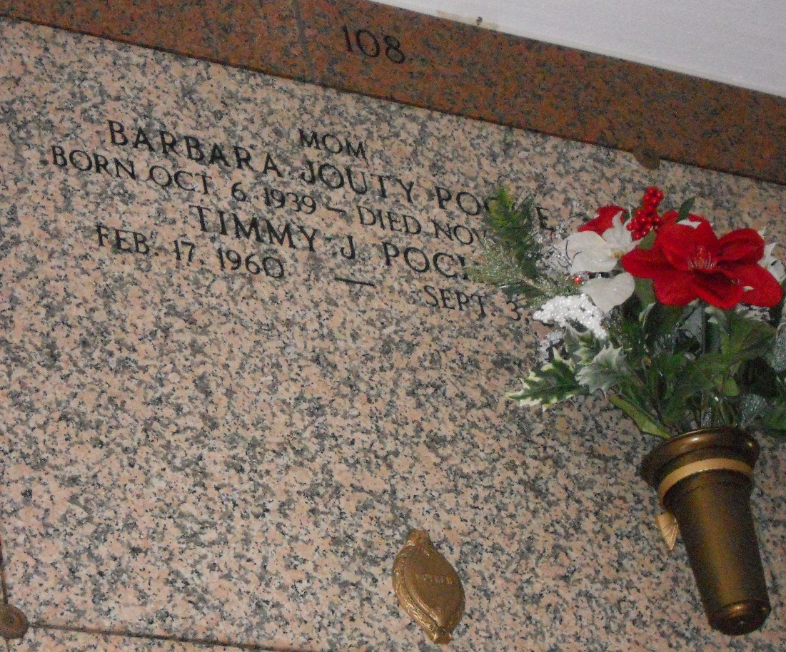

Photo by Team T-Lo

Timmy Poche passed away on Thursday, September 3, 2015. He was 55, a native of Lutcher, LA and a resident of LaPlace, LA.

Beloved son of Barbara Jouty Poche and Arnaud Poche. Brother of Rodney Poche (Sandra), Randy Poche and Trudy P. Caronna (Robert). Grandson of the late Rita and Frank Jouty and Rene 'Frere' and Ann Poche. Uncle of Dakota Poche and the late Amanda Poche. Great-uncle of Emma Poche.

The family would like to extend their heartfelt appreciation to St. Catherine's Hospice for their loving care.

Relatives and friends are invited to attend the Funeral Service at Millet-Guidry Funeral Home, 2806 W. Airline Hwy., LaPlace, LA on Wednesday, September 9, 2015 at 7:30 p.m. Visitation from 5:00 p.m. until 7:30 p.m.

New Orleans (LA) Advocate

Sep. 4 to Sep. 9, 2015