Mary (Scioneaux) Poirrier
January 14, 1936 – November 3, 2025

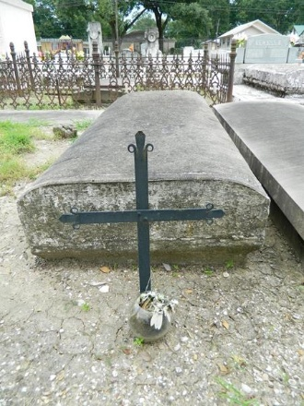

Mary Poirrier, 89, a Reserve resident, devoted catholic and cherished matriarch, passed away on November 3, 2025.
Mary was a beloved wife to the late Floyd Poirrier and a loving mother to her children: Aaron Poirrier (wife Lori), Susan Jarreau (husband Wayne), and Angela Dufresne (husband Steve). She was also the mother Cheryl Poirrier, who preceded her in death. Her life was deeply rooted in faith and family, and she found great joy in nurturing those close to her.
A lifelong member of St. Peter's Catholic Church, Mary's devotion to her faith was unwavering. Her spiritual life provided strength and guidance throughout her years.
Mary's legacy lives on the through her grandchildren: Brandon, Blake, Ashley, Angele', Michelle, John Paul, Mathew, Michael, Nicholas and step grandchildren: Stephanie, Anna and Jennifer. These grandchildren brought immense pride and happiness in her life. She also leaves behind many great grandchildren.
May Mary Poirrier's memory bring comfort to all who knew and loved her. A visitation will be held on November 7, 2025, from 9:00am to 11:00am until the funeral mass at 11:00am at St. Peter's Catholic Church, 1550 LA-44 (River Road), Reserve.

Millet Guidry Funeral Home, LaPlace, Louisiana

