Allen Joseph Poleto
June 11, 1936 - September 6, 2024

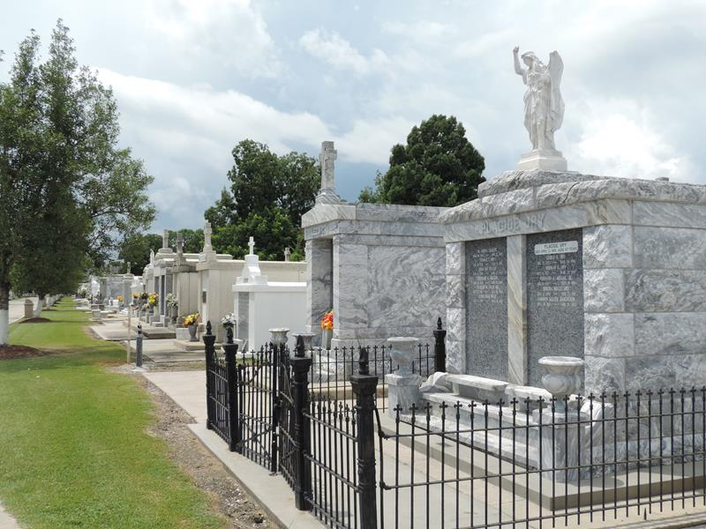

Allen Joseph “Boo” Poleto, age 88, passed away peacefully on Friday, September 6th, at his home in Metairie. Allen was born on June 11, 1936, in Garyville, LA to the late Sam and Bertha Poleto.
He is survived by his beloved life partner Margaret Reeves, children Dana (Poleto) and the late Jim Weidman of Gonzales, LA, Keith Poleto of Westwego, LA, Chris and Mary Poleto of Medford, NJ, Kim (Poleto) and Steve Mengarelli of Baton Rouge, LA. “PaPaw” to Jennifer (Weidman) Rostafin and Jamie (Weidman) Turnage, Whitney, Ella and Jack Poleto and Gabe and Sam Mengarelli and seven great grandchildren. Brother to the late Judy Poleto Toups. “Pop” to Sherri, Rick, and Nicole Boover.
Allen is a native of Garyville, LA and has been a resident of Westwego and Metairie, LA for the last 45 years. He retired from Avondale Shipyards in New Orleans in 1998.
A funeral service will be held on Monday September 16th at St. Hubert Catholic Church, 176 Anthony F Monica Street, Garyville, LA. Visitation will be held from 10:00 a.m. to 11:00 a.m. followed by a Mass of Christian Burial. Interment will follow at St. Peter Cemetery in Reserve, LA.
The family would like to offer a special thanks to all who comforted him in his final days.

Millet-Guidry Funeral Home, LaPlace, Louisiana
September 11, 2024

